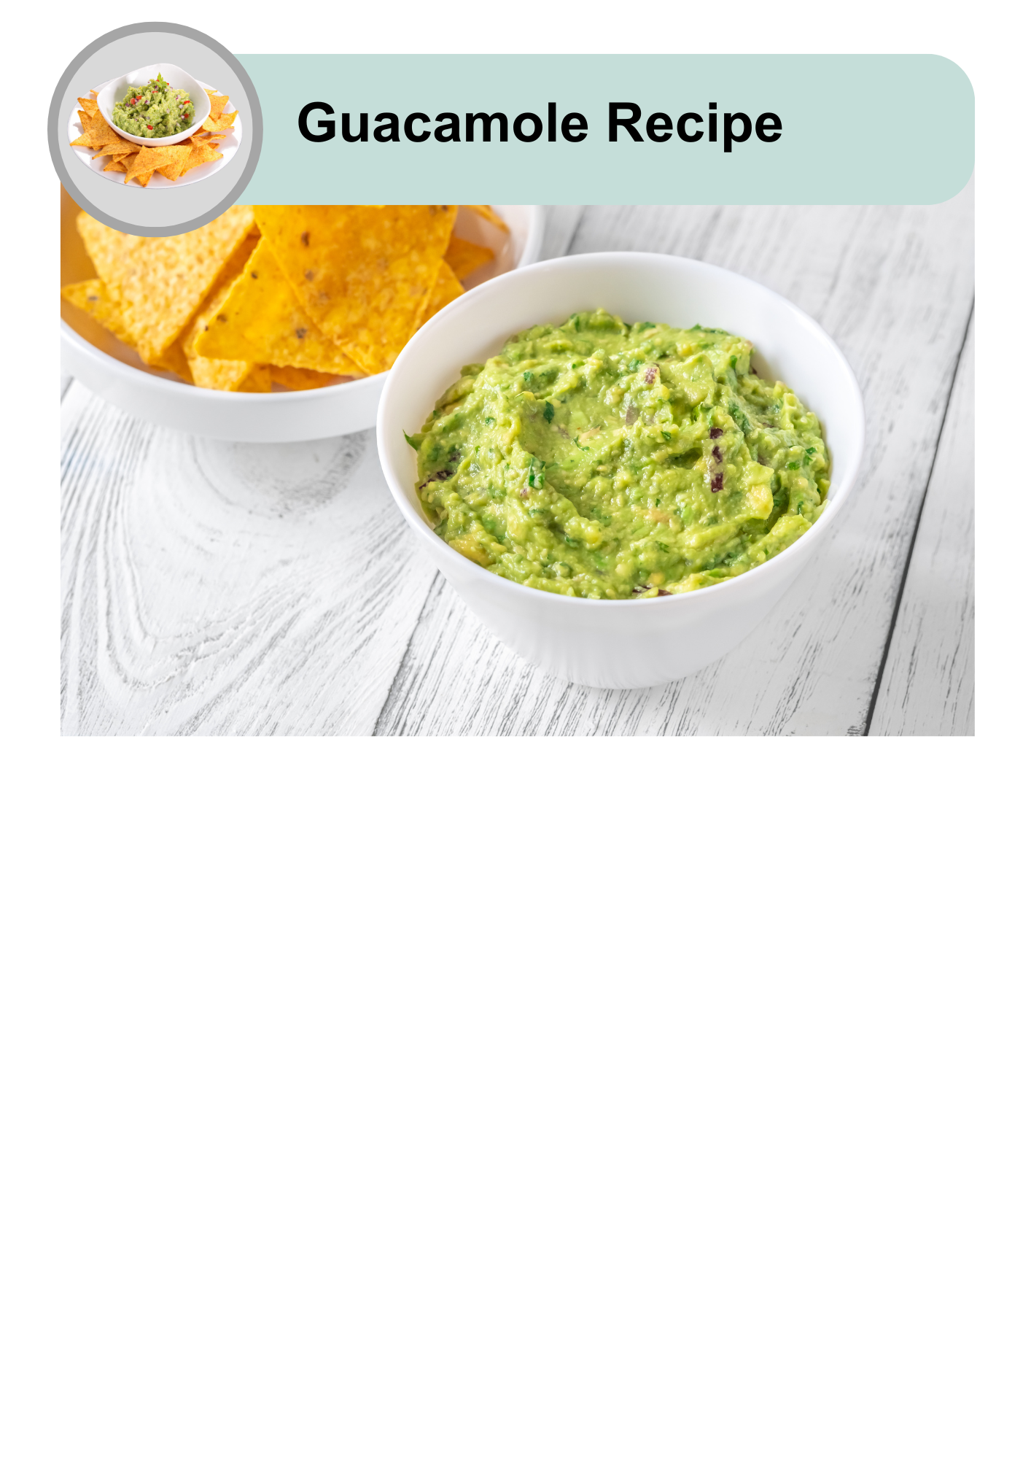

|  |  |
| --- | --- |
| A clock icon with a teal border and white face, showing a highlighted blue segment representing 5 minutes. The number '5' is displayed prominently in black with the word 'min' written below it. | This recipe takes 5 minutes to make. |
| A bowl of guacamole with six stick figure icons below, representing six servings. | It will serve 6 people. |
|  | 1 tablespoon is 1 serving. |

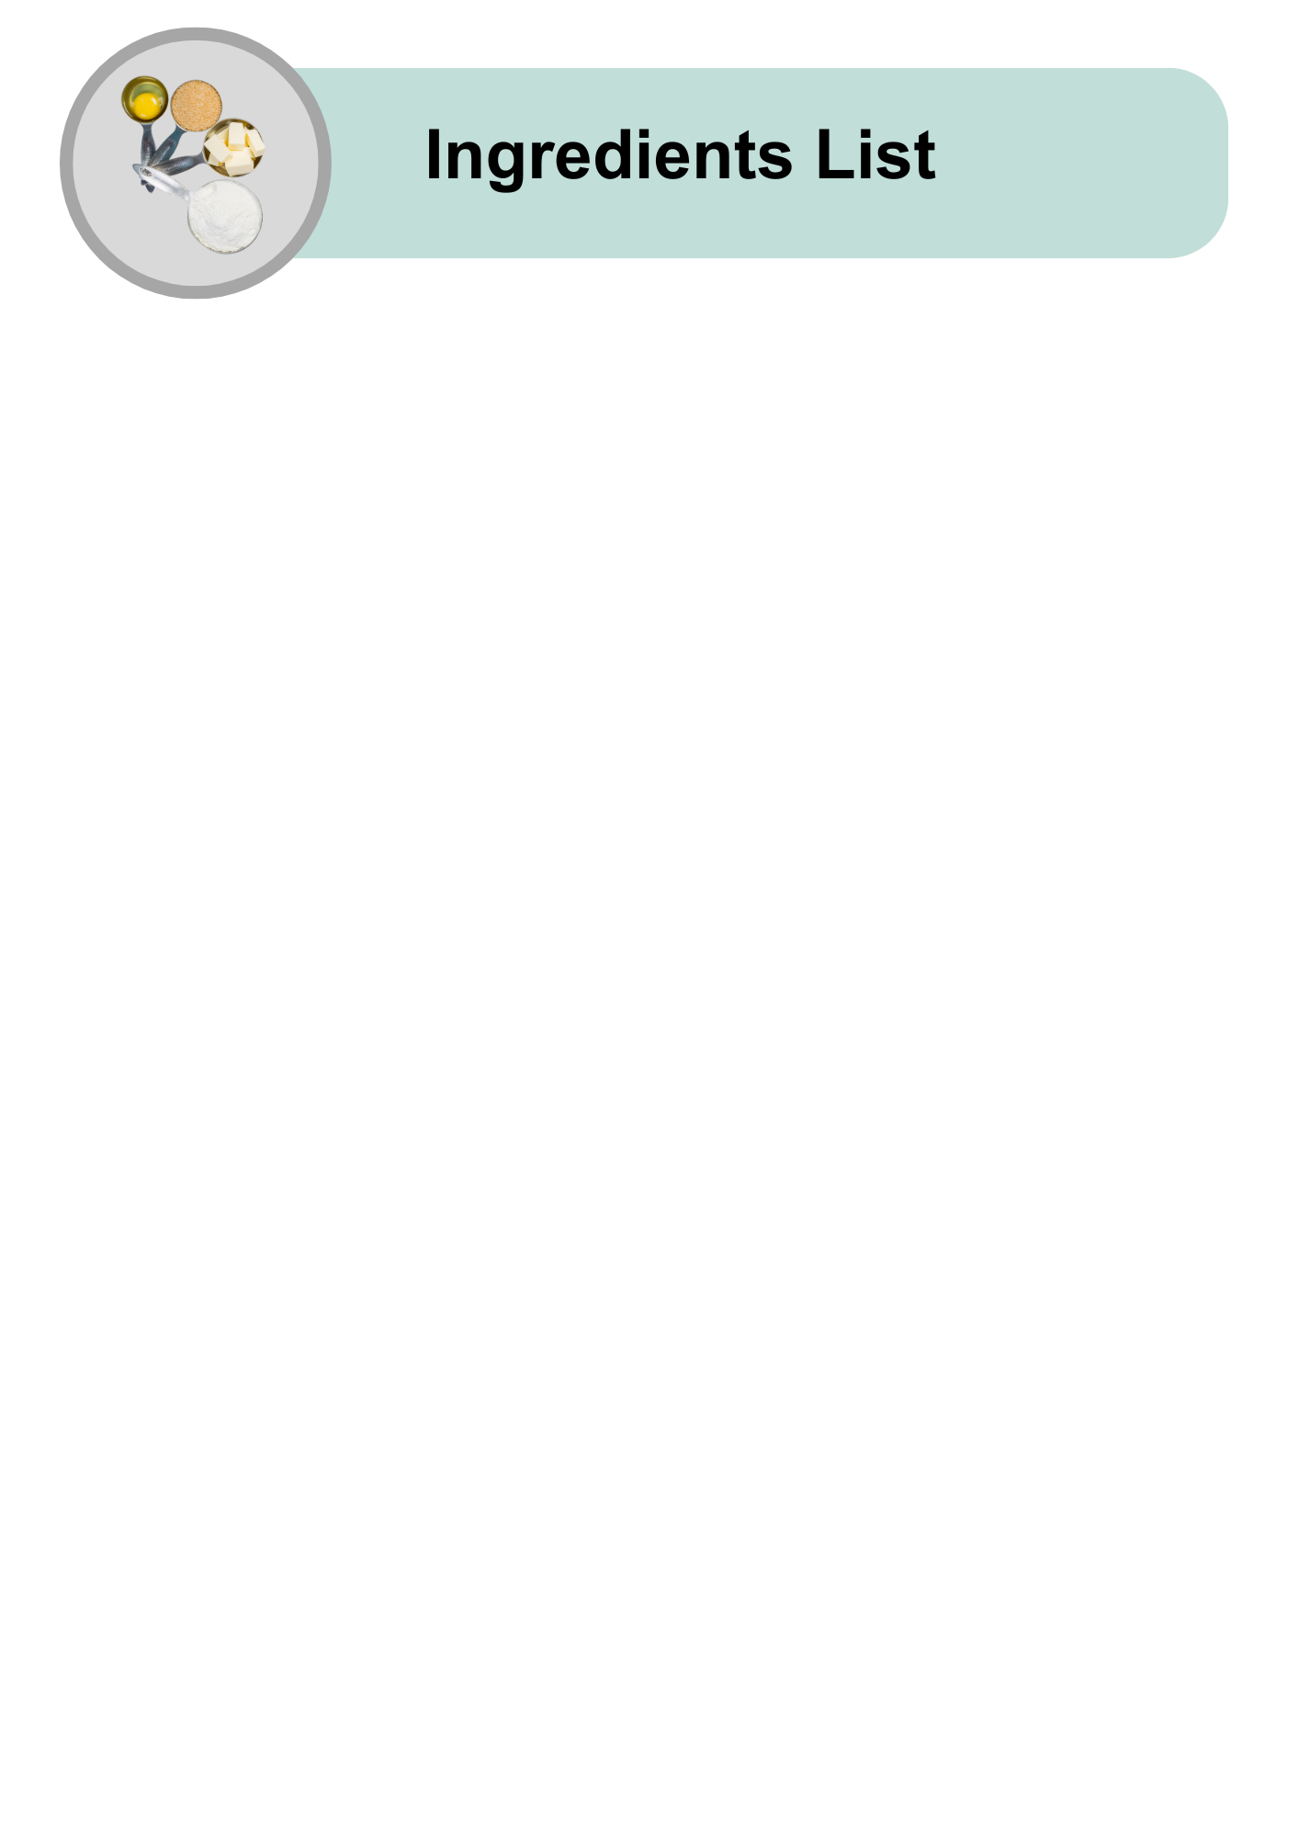

|  |  |
| --- | --- |
| A whole ripe avocado with textured green skin. | 2 avocados |
| A fresh red tomato with a green stem. | 1 medium tomato |
| A yellow lemon, shown whole and sliced in half to reveal the inner pulp. | Juice from half a lemon |
| Two red onions, one whole and one cut in half to display the layers inside. | Half a medium red onion |
| A glass shaker filled with ground black pepper, topped with a shiny silver lid, on a plain grey background. | 1 teaspoon of black pepper |
| A glass shaker filled with white table salt, topped with a shiny silver lid, on a plain grey background. | 1 teaspoon of salt |

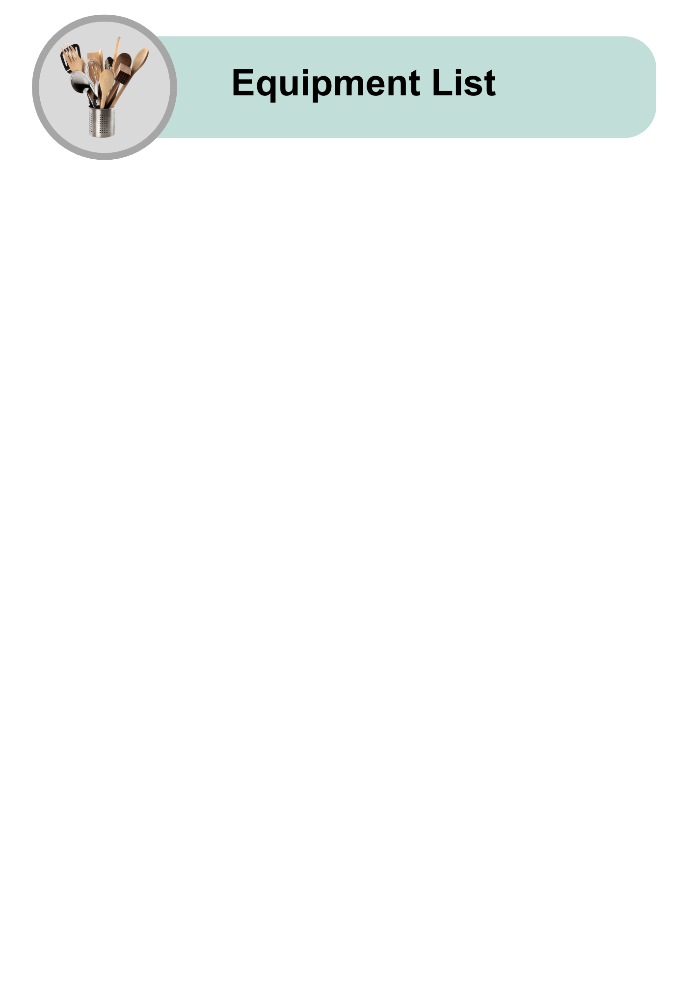

|  |  |
| --- | --- |
| A sharp paring knife with a black handle and silver blade, lying flat. | Small knife |
| A shiny silver spoon with a reflective surface and a simple design. | Metal spoon |
| A plain white ceramic bowl with a simple, clean design, placed on a light grey background. | Mixing bowl |
| A stainless steel masher with a flat, perforated mashing plate and a long handle for ease of use. | Potato masher |
| A yellow plastic citrus juicer with a ribbed cone and juice strainer, placed on a plain grey background. | Juicer |
| A rectangular wooden cutting board with a handle cutout on one side, placed on a light grey background. | Chopping board |
| A sharp chef’s knife with a wooden handle featuring a polished metal blade, placed on a light grey background. | Large knife |
| A single wooden spoon on a light grey background. | Wooden spoon |

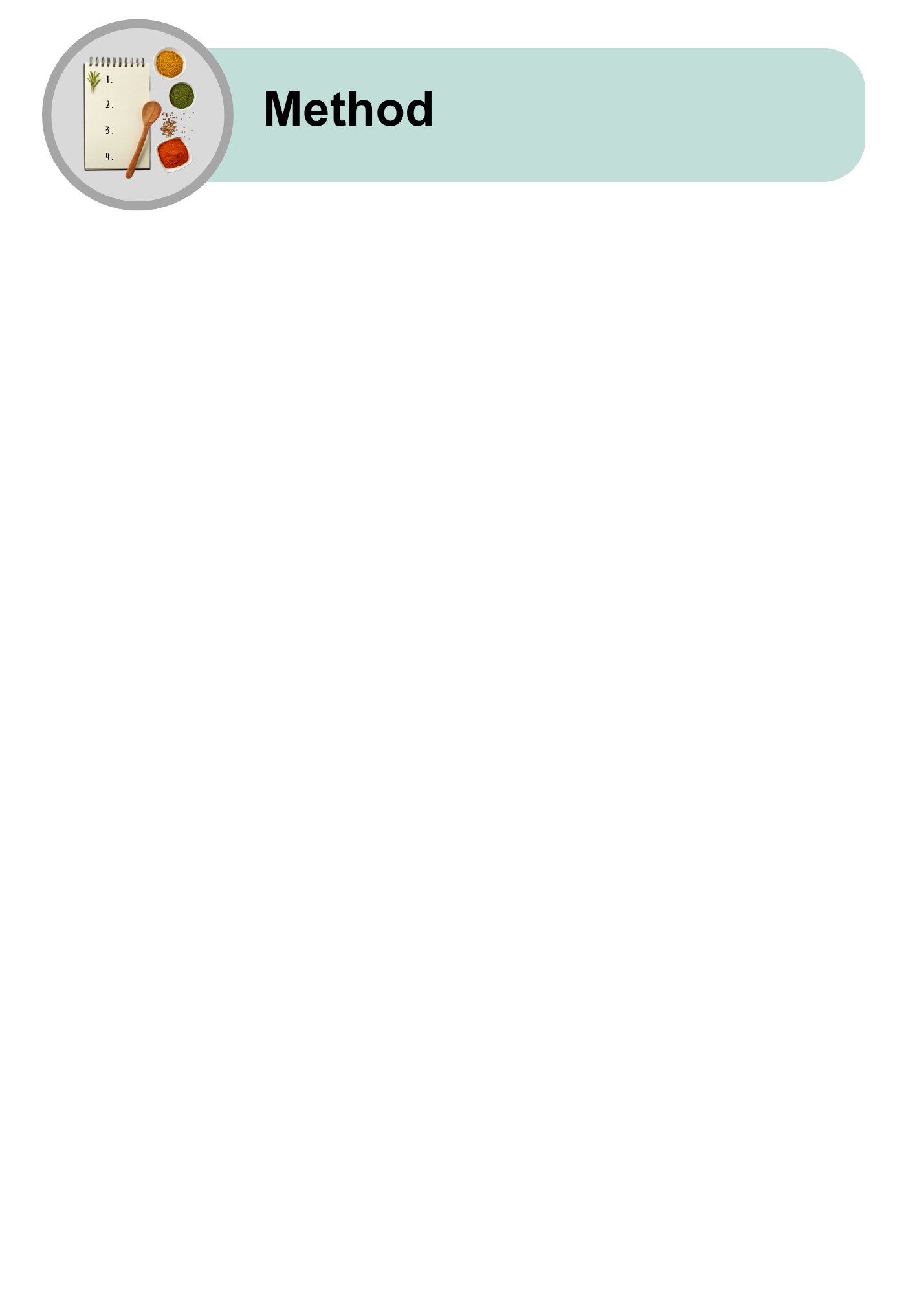

|  |  |
| --- | --- |
| A ripe avocado cut in half with a paring knife beside it, showing the seed inside. | Cut the avocados in half.  Use a small knife on a chopping board. |
| A close-up of a halved avocado with the seed removed and placed next to it on a grey background. | Take out the pit from the avocado.  Use a metal spoon. |
| A white bowl containing sliced avocado pieces with a silver spoon hovering nearby. | Scoop avocado into a bowl with a metal spoon. |
| A sequence showing avocado being mashed in a bowl with a masher or fork, ending with a bowl of smooth guacamole. | Mash the avocado.  You can use a potato masher or a fork.  Make it smooth or leave it chunky. |
| A visual step for preparing guacamole, showing lemon juice being squeezed into a bowl with a citrus juicer. | Squeeze half a lemon using a juicer.  Put lemon juice into the bowl. |
| Ingredients for guacamole preparation, including diced onion and tomato, displayed with a cutting board and knife next to a bowl. | Chop the tomato and onion into small pieces.  Add them to the bowl. |
| Seasoning step for guacamole, showing salt and pepper shakers positioned above an empty bowl. | Add some salt and pepper.  Use as much as you like. |
| A serving of freshly made guacamole garnished with diced tomatoes and herbs, ready to serve. | Mix everything together with a wooden spoon. |
| Guacamole shown as a topping for nachos, as part of a nourish bowl, and served with tortilla chips. | You can eat the guacamole:   * As a dip * With nachos * As part of a nourish bowl. |

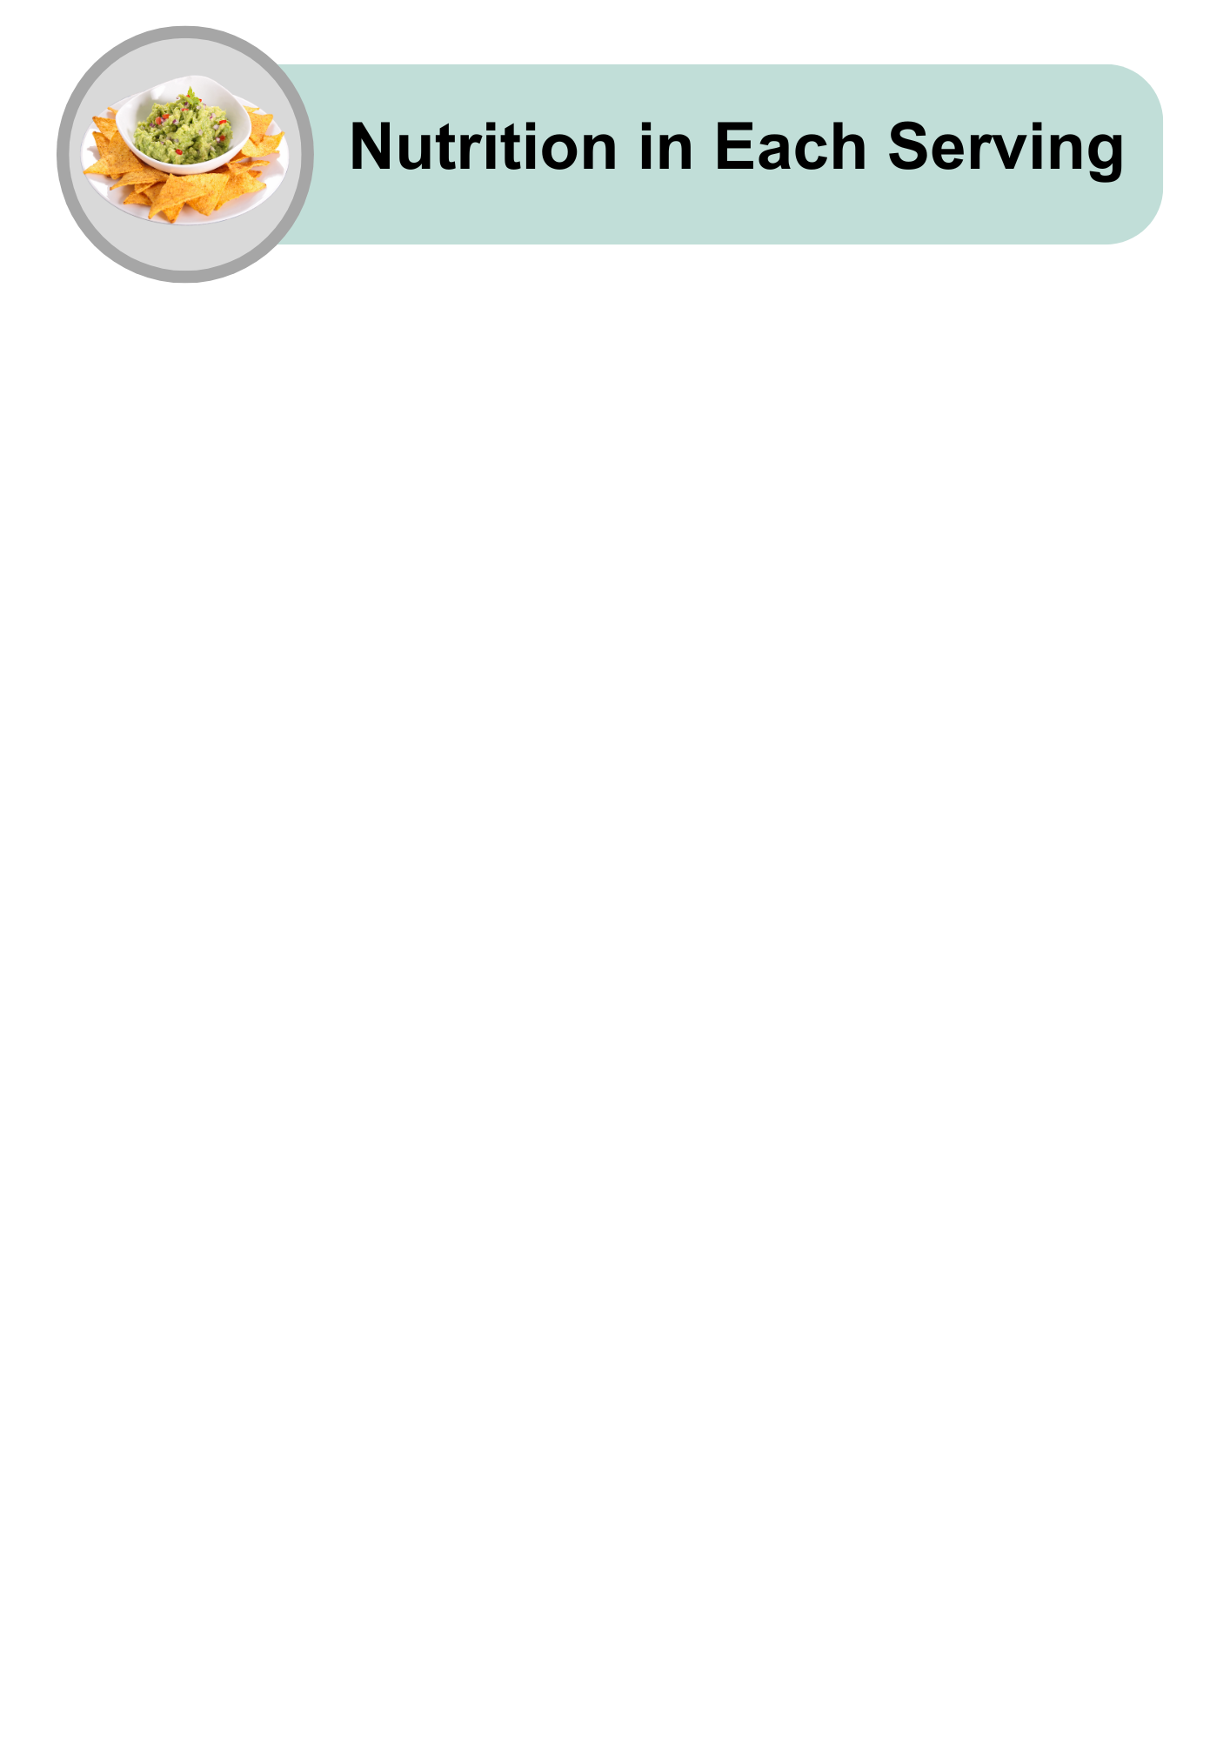

|  |  |
| --- | --- |
| A cartoon-style illustration of various foods, including chicken, fish, carrots, and an egg, with a lightning bolt icon above, representing energy or nutrients. | Quite high in energy |
| An assortment of high-protein foods, including raw salmon, chicken breast, steak, eggs, nuts, grains, and cheese, arranged on a light grey background. | Low in protein |
| A collection of healthy fat sources, including raw salmon, avocado halves, mixed nuts, and a small bowl of olive oil, placed on a light grey background. | High in healthy fat |
| A variety of carbohydrate-rich foods, including pasta, bread, cereal, cookies, juice, and sugar cubes, arranged on a light grey background. | Low in carbohydrates |
| An arrangement of sugary treats, including lollipops, chocolate, cookies, candies, and a bowl of sugar with a spoon in the centre, symbolising high-sugar foods. | Low in sugars |
| An assortment of whole grains, seeds, nuts, and breads arranged with small bowls of grains, representing healthy fibre-rich foods, on a light grey background. | A serve of fibre |
| A tilted glass shaker filled with white table salt, with a small pile of salt spilled on the grey surface, representing salt usage or measurement. | Low in salt |

|  |  |
| --- | --- |
| A bowl of guacamole with a thumbs-up hand, indicating approval. | Guacamole is easy to make and good for you! |
| A plate of tortilla chips with a bowl of guacamole in the centre. | Try making this guacamole recipe at home.  Enjoy it with your favourite meals. |
| A hand holding a smartphone displaying the Dietitians Australia website homepage, with the text 'The leading voice in nutrition and dietetics' visible on the screen. | For more recipes and tips, visit the Dietitians Australia website. |

The Australian Federation of Disability Organisations (AFDO) made this document Easy Read. You need to ask AFDO if you want to use any pictures from this document. You can email AFDO at [office@afdo.org.au](mailto:office@afdo.org.au)