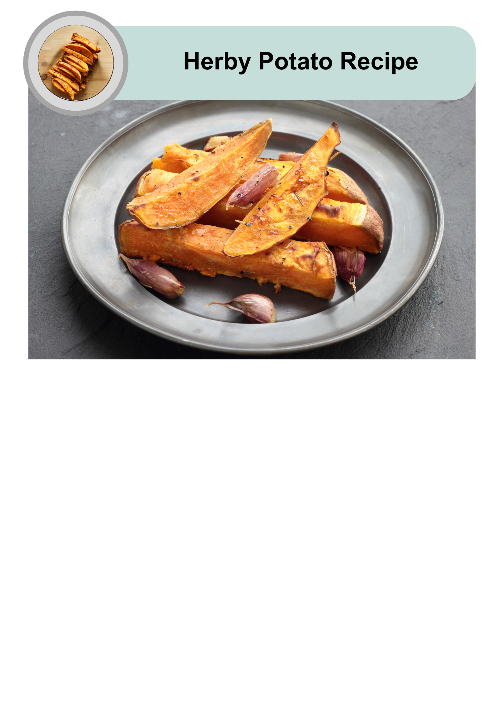

|  |  |
| --- | --- |
| A clock showing 30 minutes, indicating the total cooking time for the recipe. | This recipe takes 30 to 40 minutes to make. |
| An image of roasted herby potato wedges with four person icons below, indicating that the recipe serves four people. | It will serve 4 people. |
| A red plastic measuring cup, commonly used for measuring ingredients in cooking. | 1 cup is 1 serving. |

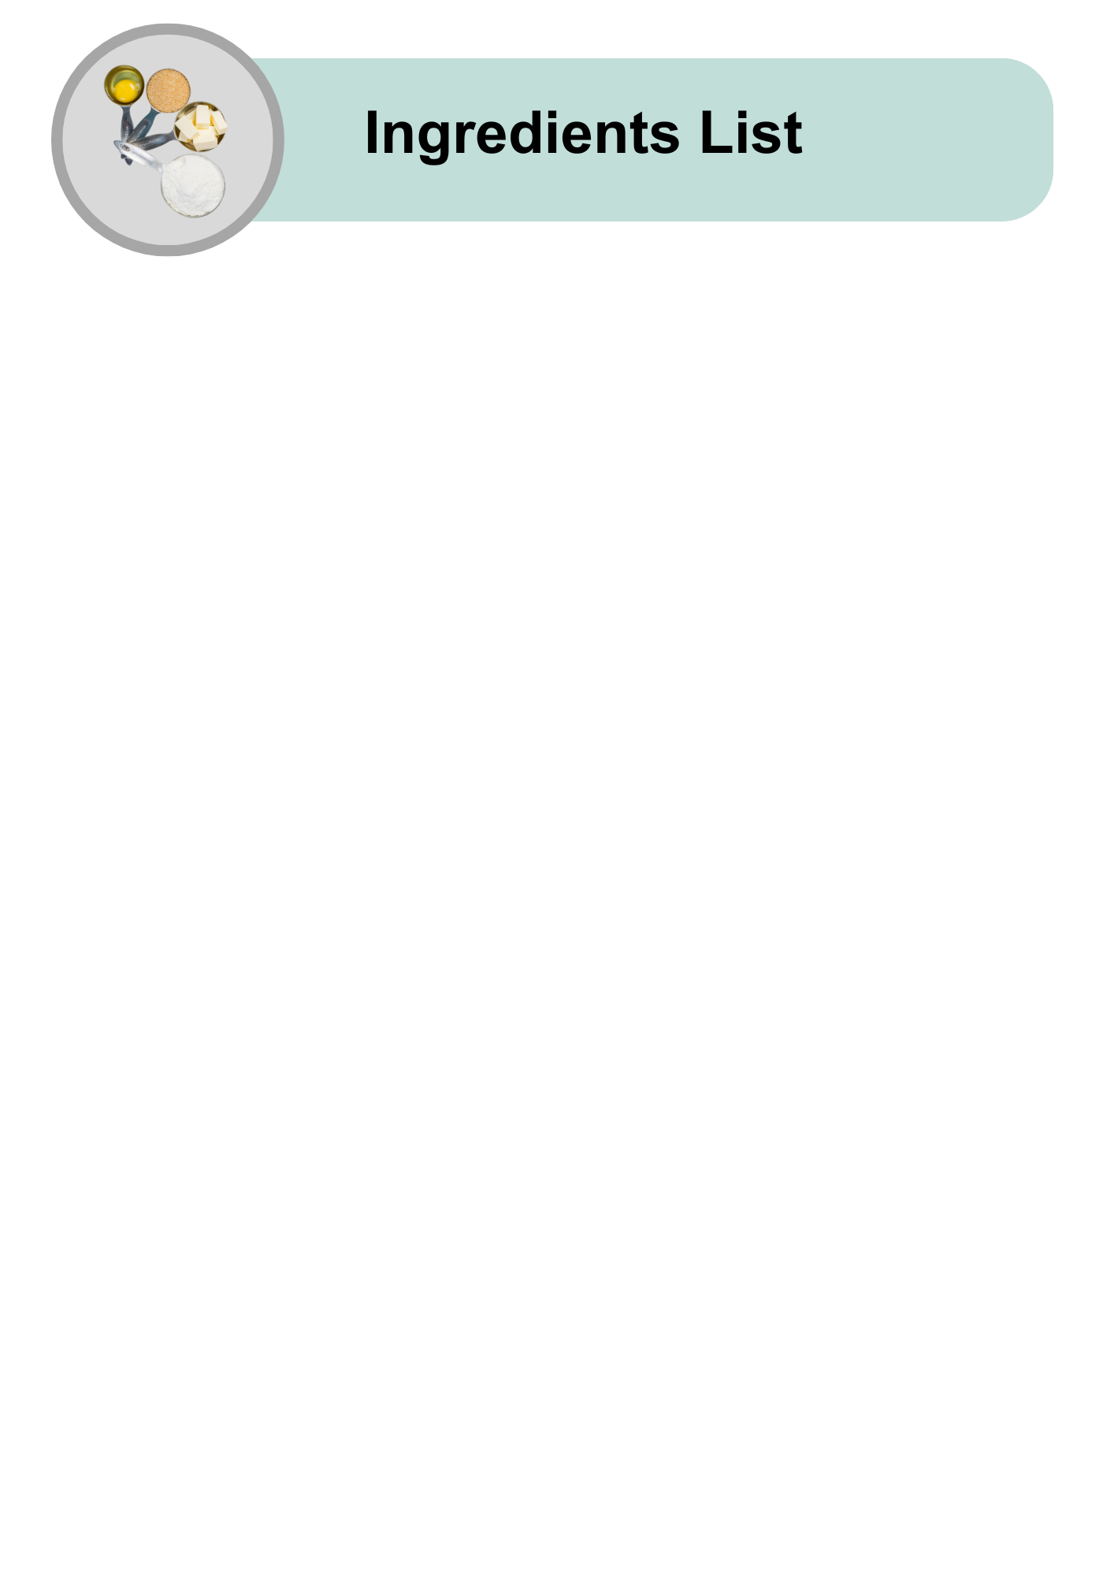

|  |  |
| --- | --- |
| A whole sweet potato with a slightly rough, reddish-brown skin, used as the main ingredient in the recipe. | 1 medium sweet potato |
| A whole red-skinned potato. | 1 medium potato with red skin |
| A whole white-skinned potato. | 1 medium potato with white skin |
| A silver measuring spoon filled with golden olive oil, placed on a plain grey background. | 1 to 2 tablespoons of Extra Virgin Olive Oil |
| A small red and white measuring spoon filled with dried herbs. | 1 tablespoon of mixed herbs |

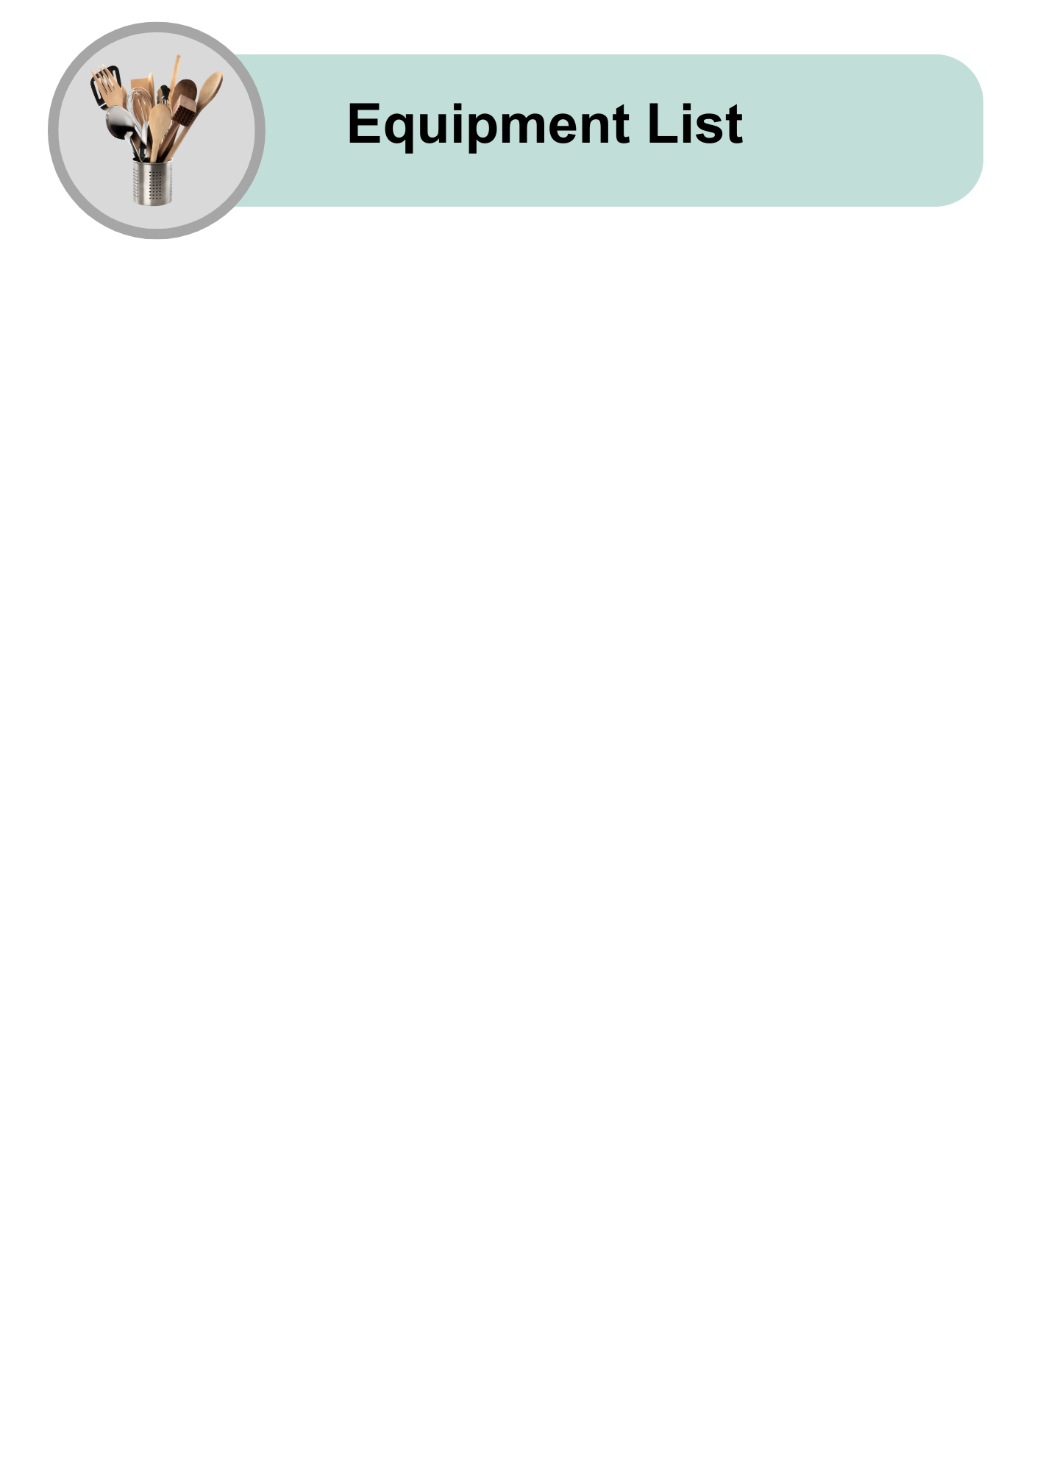

|  |  |
| --- | --- |
| A silver kitchen oven with a digital display. | Oven |
| A rectangular wooden cutting board with a handle cutout on one side, placed on a light grey background. | Chopping board |
| A sharp chef’s knife with a wooden handle featuring a polished metal blade, placed on a light grey background. | Large knife |
| A black non-stick baking tray. | Large flat oven-proof dish |
| A shiny metal spoon with a simple, reflective design, placed on a light grey background. | Tablespoon |
| A plain white ceramic bowl with a simple, clean design, placed on a light grey background. | Large bowl |
| A smiling woman wearing a red and white striped apron, holding two wooden spoons while stirring a pot. She is surrounded by fresh vegetables, including tomatoes, bell peppers, cucumbers, and a cabbage, on a grey background. | A support person to help use the oven safely |

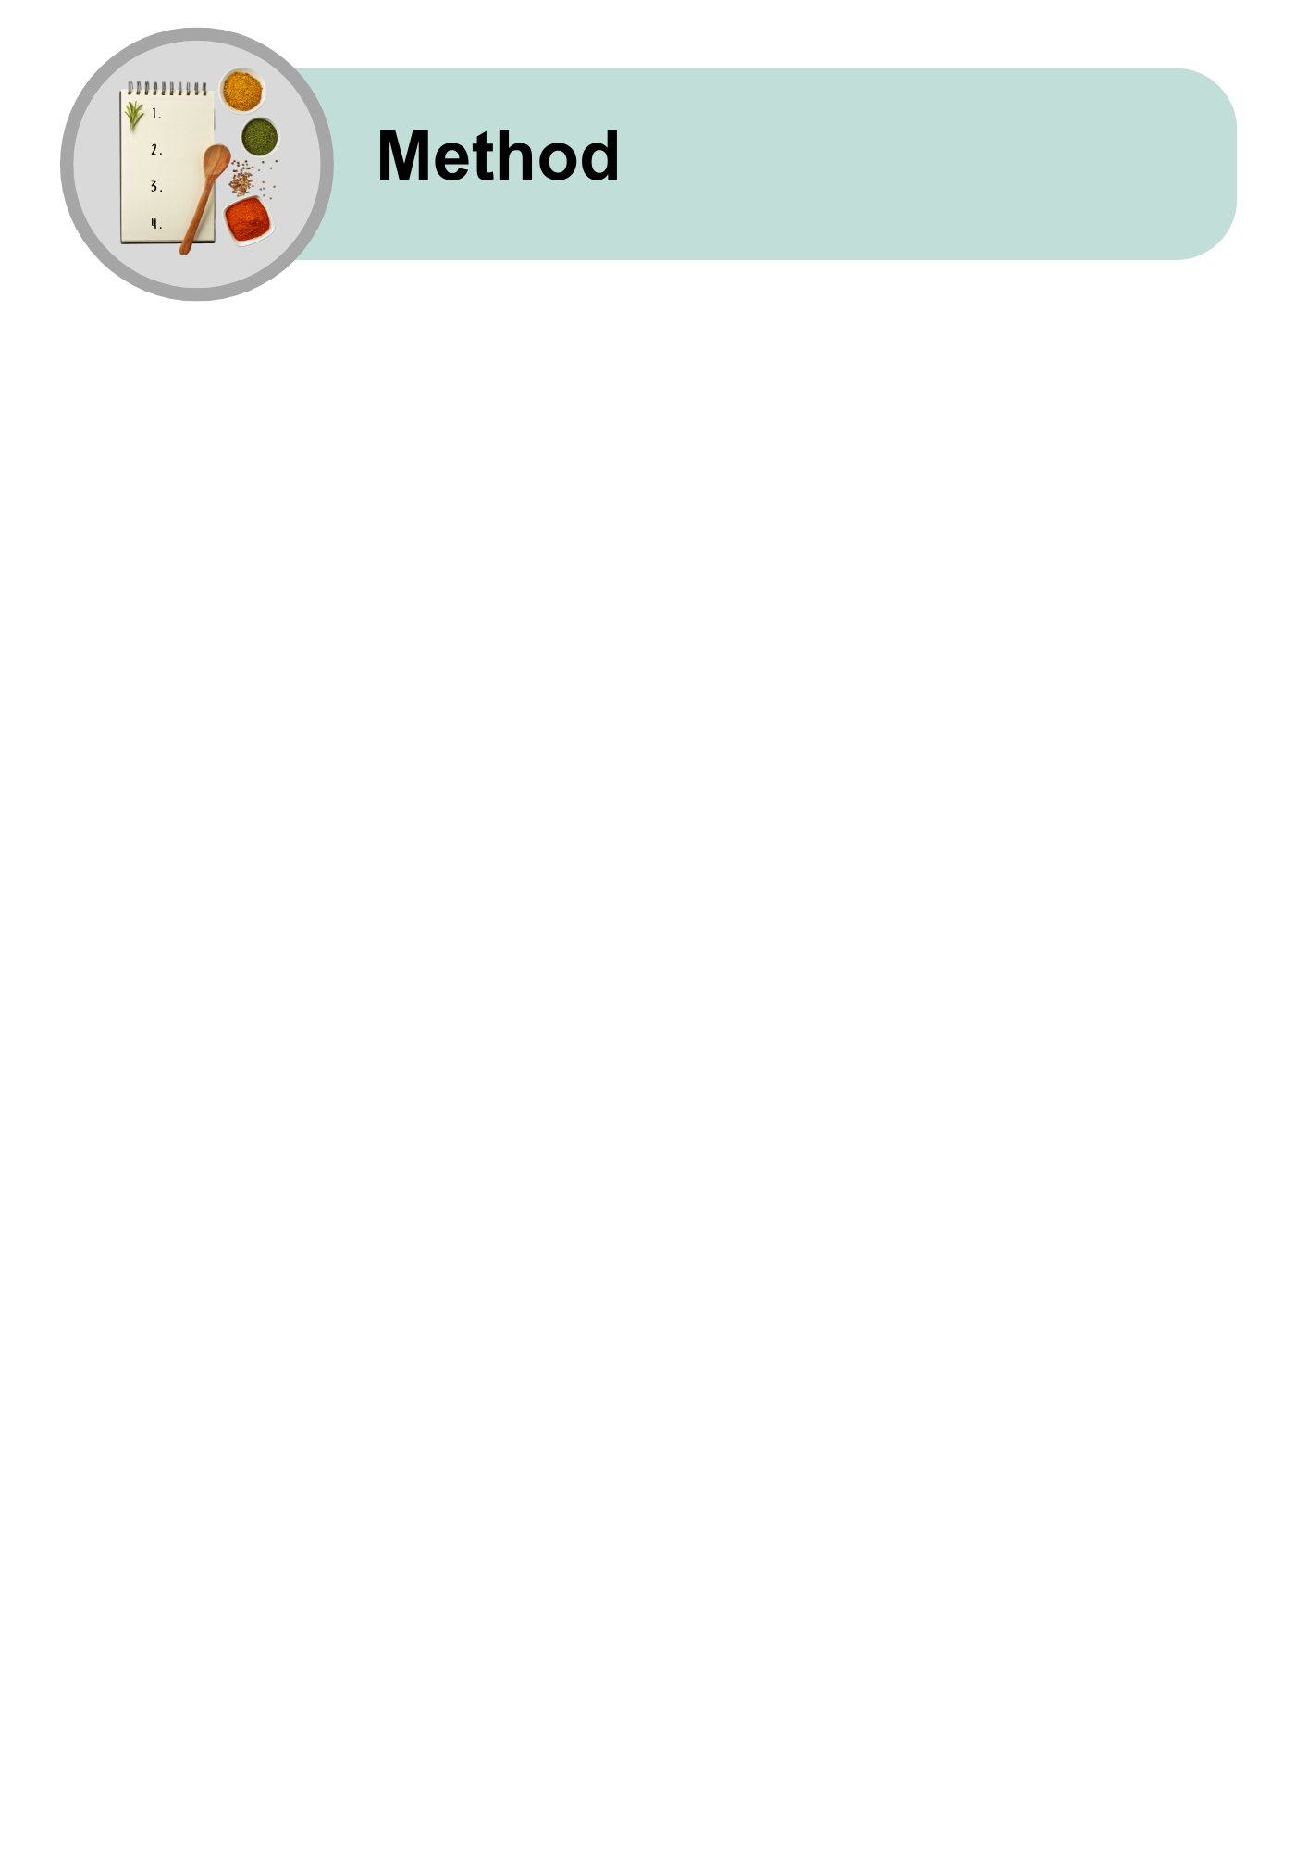

|  |  |
| --- | --- |
| A silver oven with "180°" written above, indicating the need to preheat it to 180 degrees Celsius. | Turn the oven to 180 C. |
| A person slicing a white potato into rounds on a wooden chopping board. | Cut the potatoes: |
| A person chopping an orange sweet potato into wedges on a wooden chopping board. | * Make them into thick chips. |
| A whole red-skinned potato with a green checkmark, indicating it is the right choice for the recipe. | * Leave the skin on. |
| An image of cut sweet potato wedges being placed into a white mixing bowl. | Put the potatoes in a large bowl. |
| A composition of olive oil, dried herbs, salt, and pepper being added to a bowl of cut sweet potatoes. | Add:   * olive oil * mixed herbs * salt * and pepper. |
| A spoon stirring sweet potato wedges in a bowl, ensuring even coating with seasoning. | Mix the potatoes with a spoon or your hands. |
| Seasoned potato wedges being moved from a bowl to a black baking tray. | Put the potatoes on a baking dish. |
| A baking tray of potatoes being placed into an oven with a gloved hand. | Ask your support person for help to put the dish in the oven. |
| An oven icon with two clocks showing 30 to 40 minutes, indicating the required baking time. | Cook for 30 to 40 minutes until crispy. |
| A vertical arrangement of four meal options, showing different ways to eat herby potatoes. From top to bottom:  Grilled chicken wings with chips and dipping sauce. A salad with greens, sweet potato, avocado, and dressing. A wrap filled with grilled meat and fresh vegetables. A nourish bowl with grains, legumes, and colourful vegetables. | You can eat the herby potatoes:   * With grilled chicken or fish * With a salad * In a wrap with veggies * As part of a nourish bowl. |

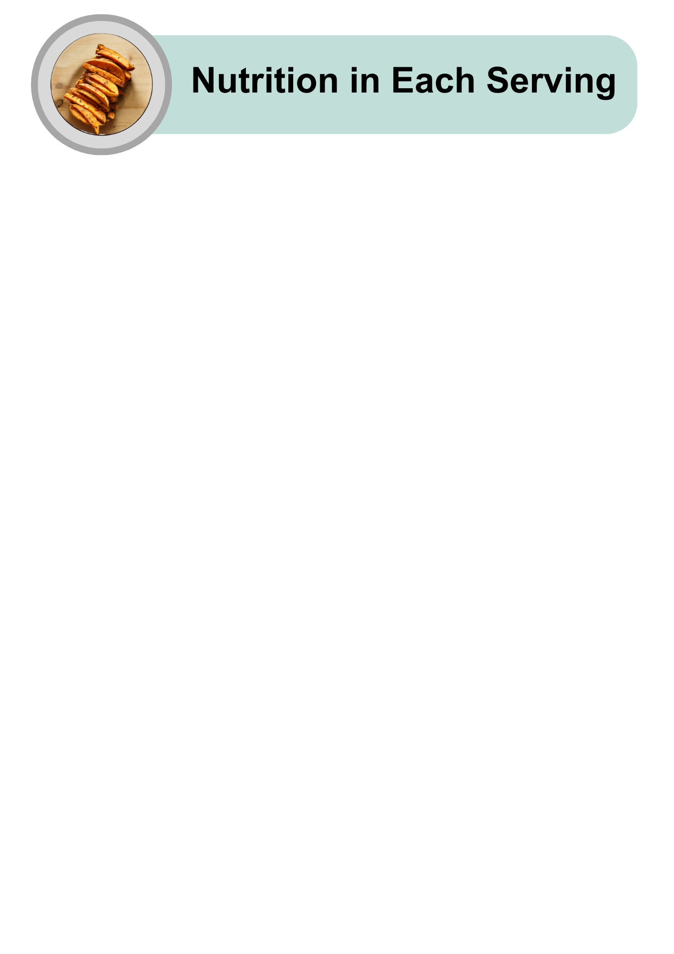

|  |  |
| --- | --- |
| A cartoon-style illustration of various foods, including chicken, fish, carrots, and an egg, with a lightning bolt icon above, representing energy or nutrients. | Quite high in energy |
| An assortment of high-protein foods, including raw salmon, chicken breast, steak, eggs, nuts, grains, and cheese, arranged on a light grey background. | Low in protein |
| A collection of healthy fat sources, including raw salmon, avocado halves, mixed nuts, and a small bowl of olive oil, placed on a light grey background. | Low in fat |
| A variety of carbohydrate-rich foods, including pasta, bread, cereal, cookies, juice, and sugar cubes, arranged on a light grey background. | Quite high in carbohydrates |
| An arrangement of sugary treats, including lollipops, chocolate, cookies, candies, and a bowl of sugar with a spoon in the centre, symbolising high-sugar foods. | Low in sugars |
| An assortment of whole grains, seeds, nuts, and breads arranged with small bowls of grains, representing healthy fibre-rich foods, on a light grey background. | High in fibre |
| A tilted glass shaker filled with white table salt, with a small pile of salt spilled on the grey surface, representing salt usage or measurement. | Low in salt |

|  |  |
| --- | --- |
| A hand giving a thumbs-up with a plate of roasted herby potatoes in a circle. | Herby Potatoes are easy to make and good for you! |
| A plate of crispy herby potato fries with a small bowl of dipping sauce. | Try making this recipe at home.  Enjoy it with your favourite meals. |
| A hand holding a smartphone displaying the Dietitians Australia website homepage, with the text 'The leading voice in nutrition and dietetics' visible on the screen. | For more recipes and tips, visit the Dietitians Australia website. |

The Australian Federation of Disability Organisations (AFDO) made this document Easy Read. You need to ask AFDO if you want to use any pictures from this document. You can email AFDO at [office@afdo.org.au](mailto:office@afdo.org.au)