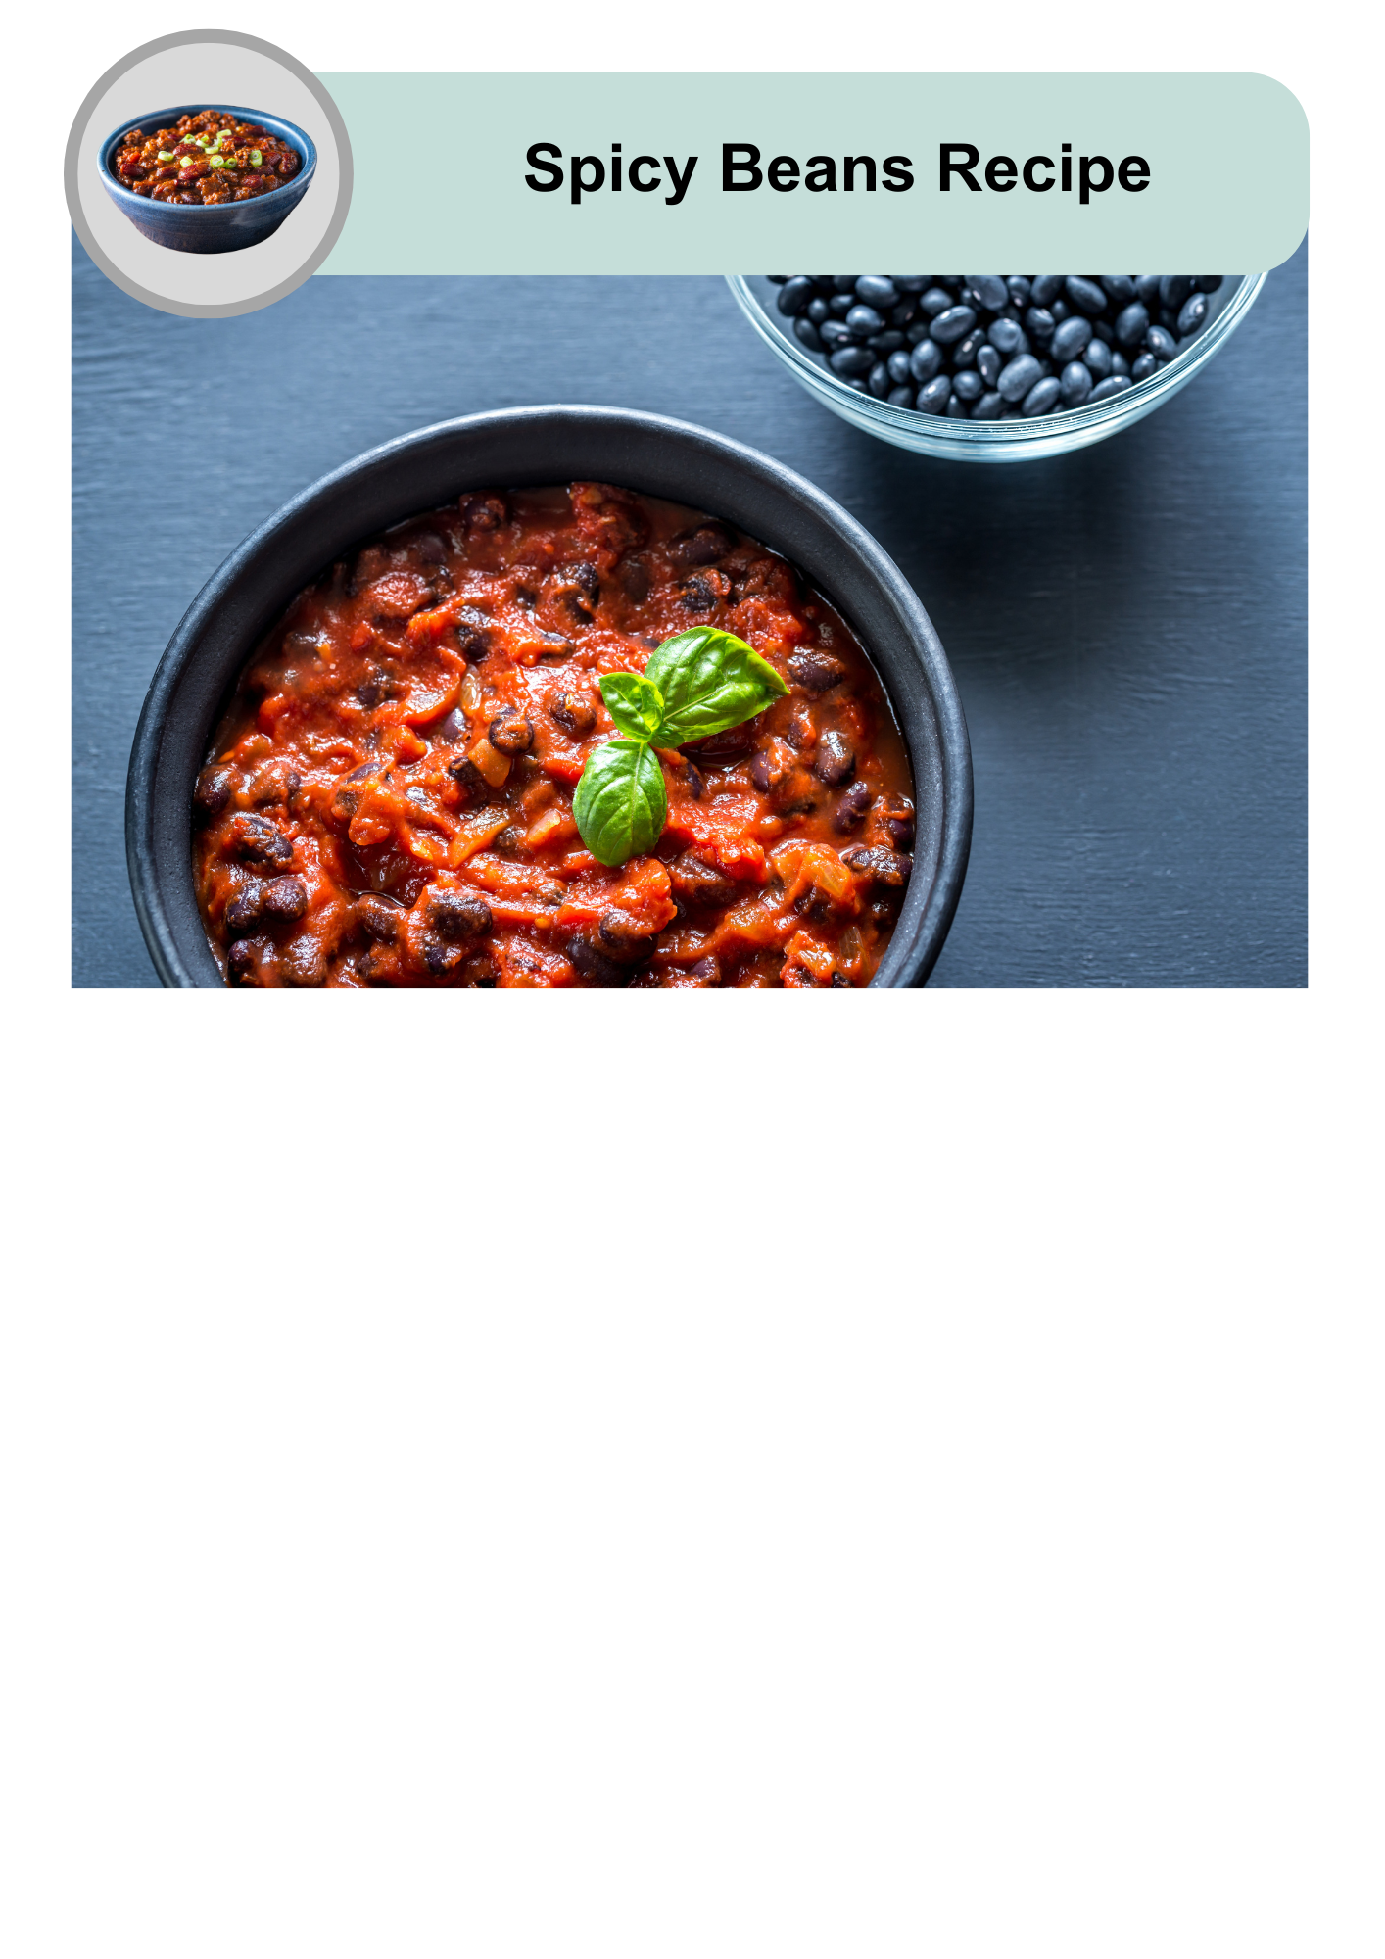

|  |  |
| --- | --- |
| A clock icon showing "15 min" in blue, indicating the time required to prepare the Spicy Beans recipe. | This recipe takes 10 to 15 minutes to make. |
| An image of a bowl filled with spicy beans, accompanied by four black silhouette figures, indicating that the recipe serves four people. | It will serve 4 people. |
| A red plastic measuring cup. | 1 cup is 1 serving. |

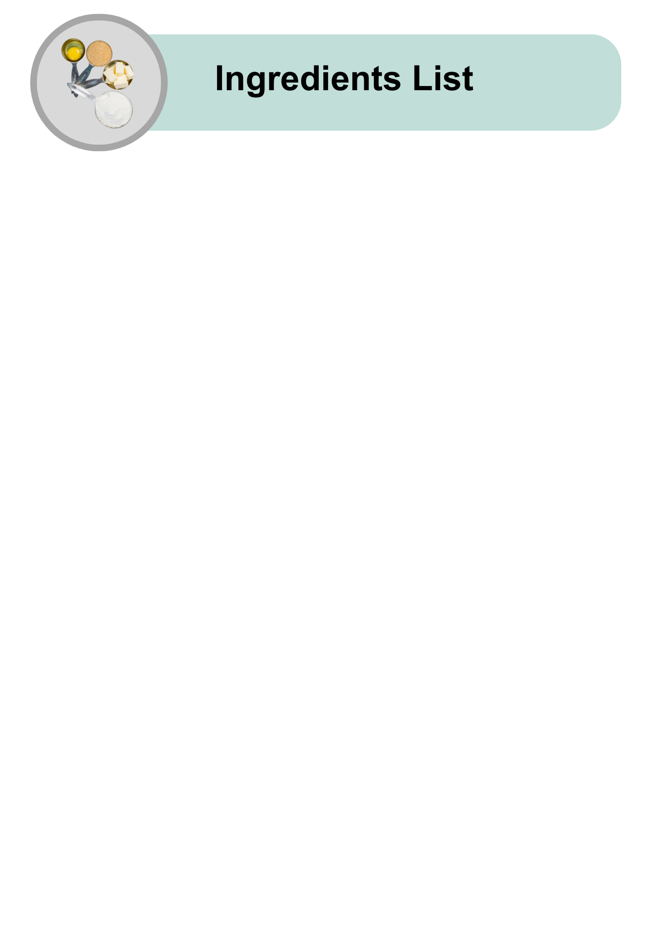

|  |  |
| --- | --- |
| A sliced red onion showing its layers, an ingredient for the spicy beans recipe. | Half a red onion |
| A silver spoon filled with oil, representing an ingredient in the recipe. | 1 teaspoon of olive oil |
| A can of dark black beans with the lid pulled back, used for the spicy beans recipe. | 1 tin of black beans (400g) |
| A can of whole peeled tomatoes with the lid open, used in the spicy beans recipe. | 1 tin of diced tomatoes (400g) |
| Two ornate silver spoons filled with a Mexican Spice Mix, used to season the spicy beans. | 2 teaspoons of Mexican spice mix |

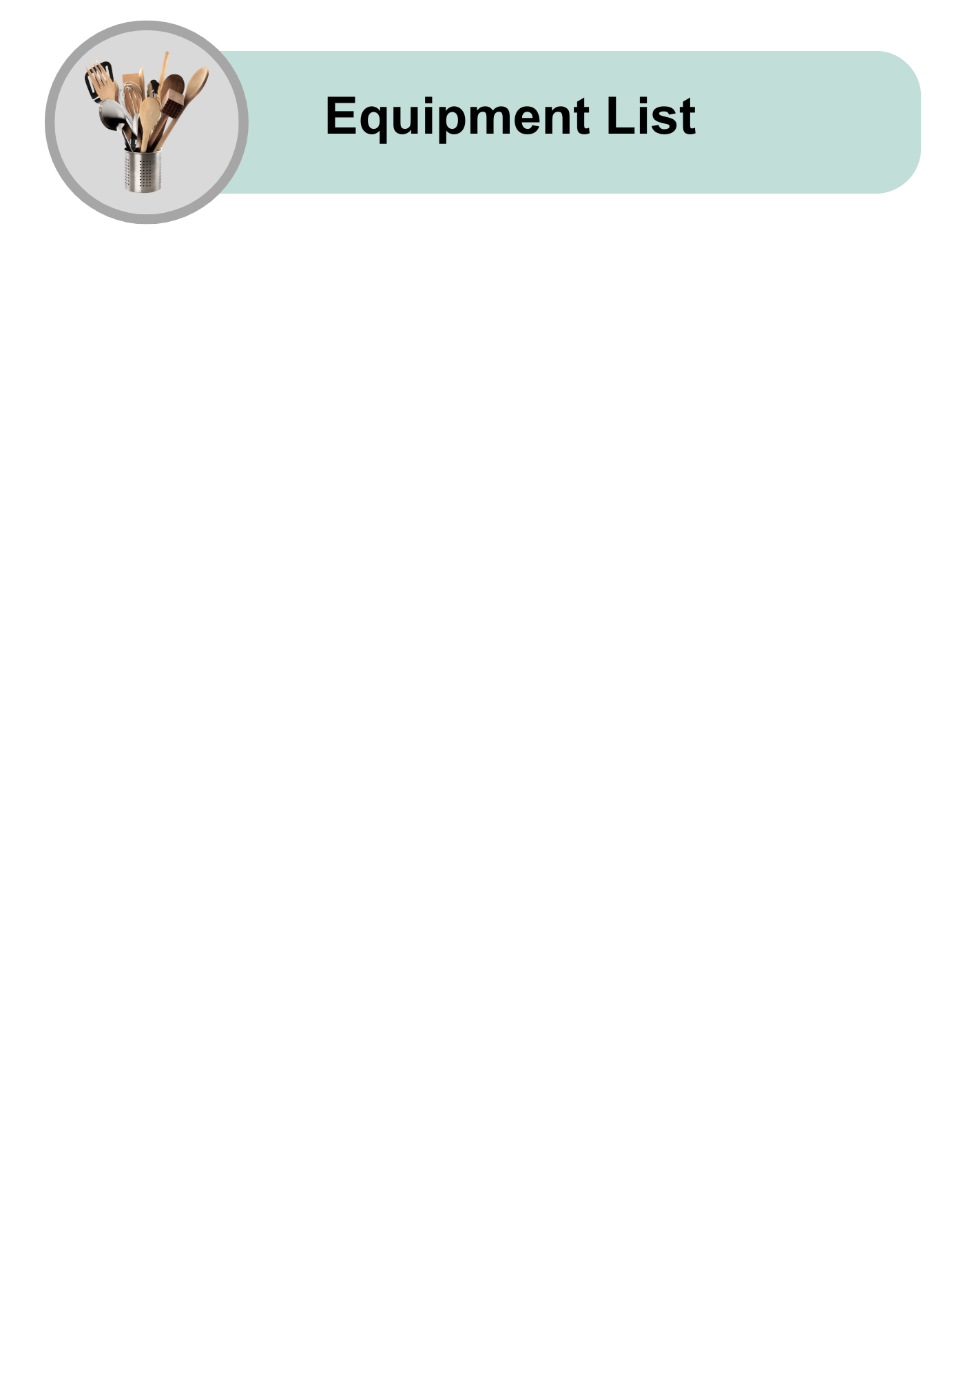

|  |  |
| --- | --- |
| A wooden chopping board with a handle. | Chopping board |
| A sharp chef’s knife with a wooden handle. | Sharp knife |
| A red metal colander with handles, used for draining ingredients. | Colander or strainer |
| A four-burner gas stovetop with control knobs. | Stove |
| A red saucepan with a black handle. | Medium saucepan |
| A silver spoon with a reflective surface. | Large spoon |
| A smiling woman in a red striped apron, cooking in a pot surrounded by fresh vegetables. | A support person to help |

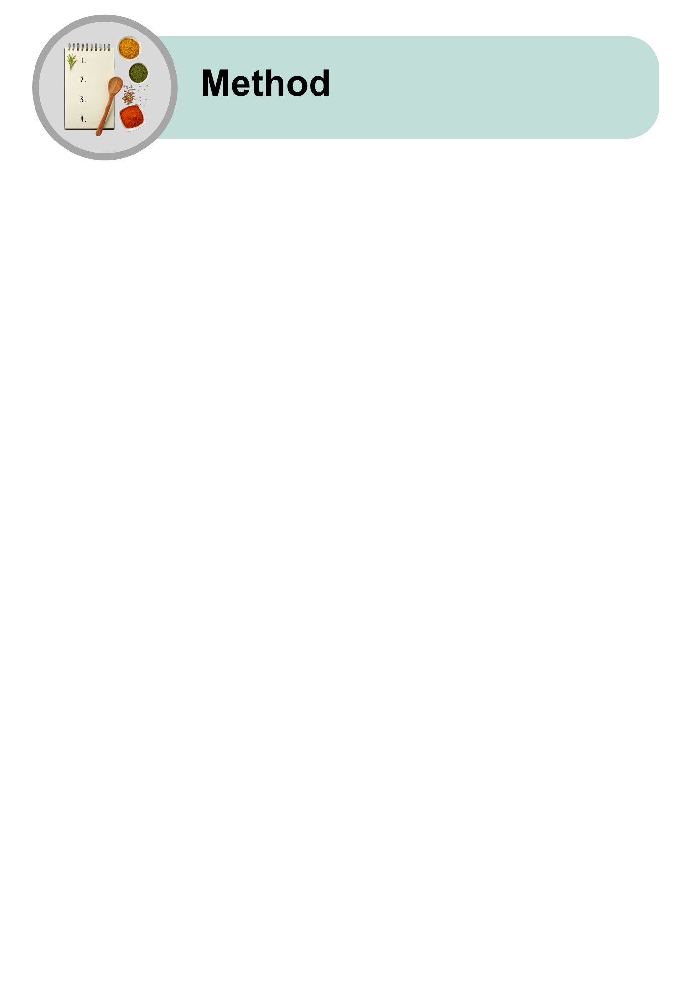

|  |  |
| --- | --- |
| A whole red onion and a pile of diced onion, with a knife and a wooden chopping board. | Chop the onion into small pieces. |
| A can of red kidney beans with a warning symbol about the sharp can lid, and a person cooking. | Open the tin of black beans.  The tin can be sharp.  Ask for help if needed. |
| A sharp can lid being placed into a bin with a red arrow. | Put the tin in the bin safely. |
| A can of beans being emptied into a red colander. | Pour the beans into a colander to drain. |
| Water running from a tap over beans in a colander. | Rinse the beans with water to clean them. |
| A gas stove with a flame icon labeled "ON" and a person cooking. | Turn on the stove.  Set the heat to medium.  As for help if you need it. |
| A diagram showing a spoonful of oil being added to a red saucepan. The saucepan is then placed on a stove with a timer icon indicating 1 minute. | Put the saucepan on the stove.  Add 1 teaspoon of olive oil.  Let it heat for 1 minute. |
| A diagram showing chopped onion being added to a saucepan. The saucepan is placed on a stove with a timer icon indicating 2 minutes. | Put the chopped onion to the saucepan.  Cook the onion for 2 minutes until it is soft.  Stir sometimes with a spoon. |
| A diagram showing a can of beans, a can of tomatoes, and two spoons of spice being added to a saucepan. | Into the saucepan put:   * Diced tomatoes * Rinsed beans * Mexican spice mix. |
| A diagram showing a saucepan with a spoon stirring inside, with arrows indicating a circular motion. | Stir with the spoon to mix everything. |
| A diagram showing the saucepan on a stove with a timer icon indicating 5 minutes and a stirring motion. | Cook for 5 to 7 minutes until the beans are hot and soft.  Stir sometimes. |
| A diagram showing the cooked mixture being transferred from the saucepan into a blue bowl. | Put the spicy beans in a bowl. Keep them warm until ready to eat. |
| A diagram showing the cooked spicy beans being transferred from a red saucepan into a blue bowl. Text underneath suggests different ways to eat the beans: with rice, in a burrito, or as part of a nourish bowl. | You can eat the spicy beans:   * With rice * In a burrito * As part of a nourish bowl. |

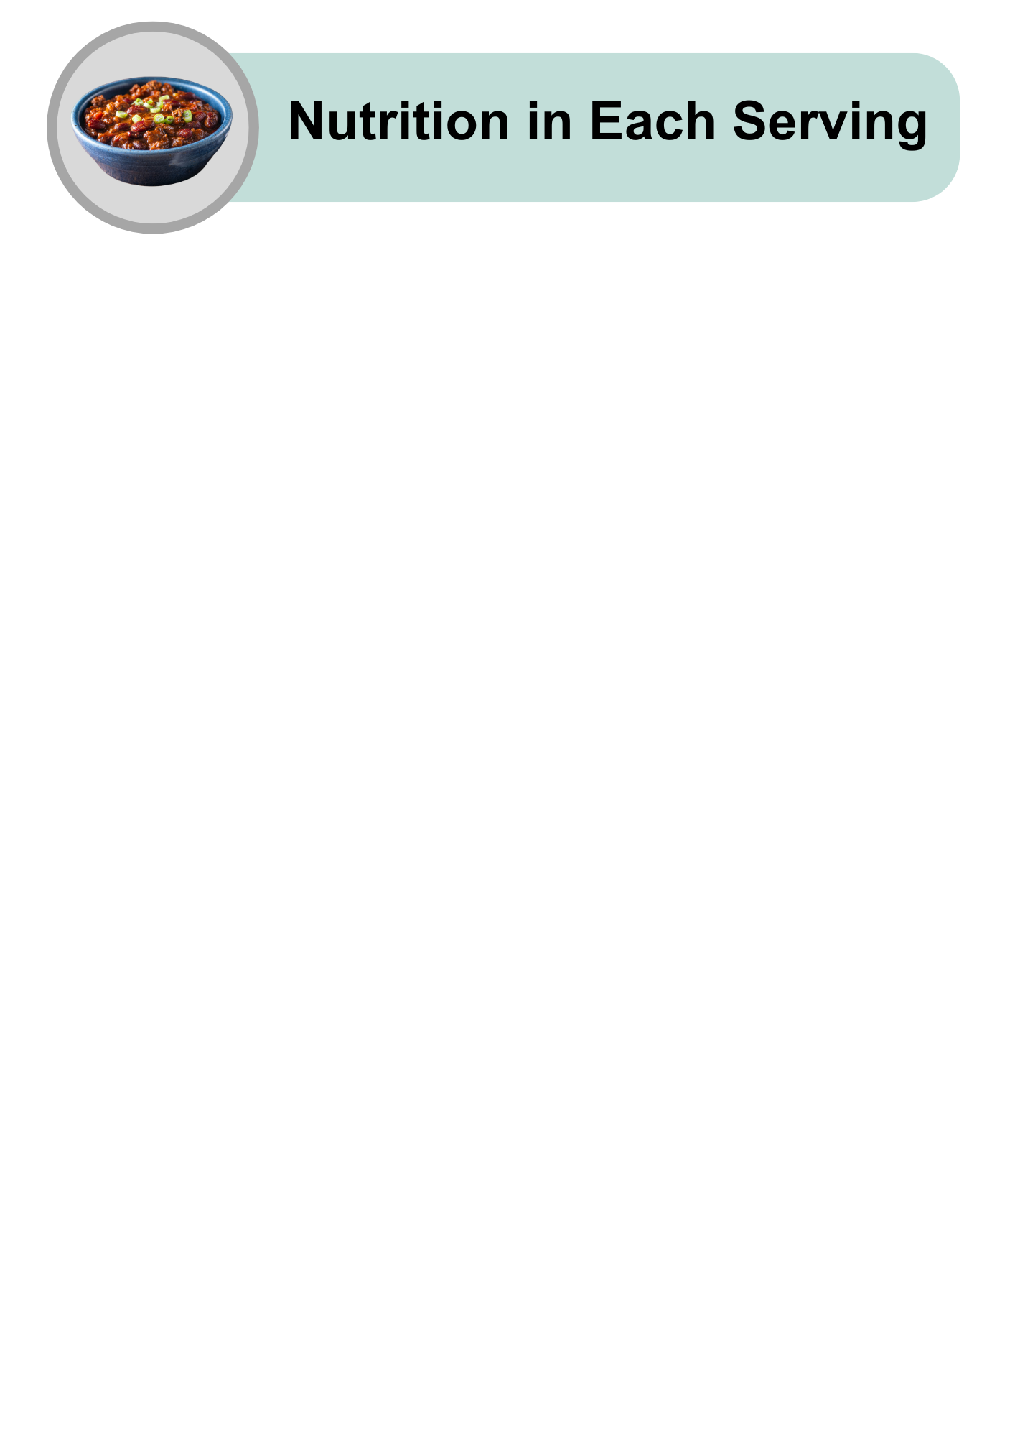

|  |  |
| --- | --- |
| A cartoon-style illustration of various foods, including chicken, fish, carrots, and an egg, with a lightning bolt icon above, representing energy or nutrients. | Quite high in energy |
| An assortment of high-protein foods, including raw salmon, chicken breast, steak, eggs, nuts, grains, and cheese, arranged on a light grey background. | High in protein |
| A collection of healthy fat sources, including raw salmon, avocado halves, mixed nuts, and a small bowl of olive oil, placed on a light grey background. | Low in fat |
| A variety of carbohydrate-rich foods, including pasta, bread, cereal, cookies, juice, and sugar cubes, arranged on a light grey background. | High in carbohydrates |
| An arrangement of sugary treats, including lollipops, chocolate, cookies, candies, and a bowl of sugar with a spoon in the centre, symbolising high-sugar foods. | Low in sugars |
| An assortment of whole grains, seeds, nuts, and breads arranged with small bowls of grains, representing healthy fibre-rich foods, on a light grey background. | High in fibre |
| A tilted glass shaker filled with white table salt, with a small pile of salt spilled on the grey surface, representing salt usage or measurement. | Low in salt |
| A bowl of spicy beans with a thumbs-up gesture. | Spicy beans are easy to make and good for you! |
| A close-up image of the finished spicy beans, garnished with fresh basil. | Try making this recipe at home.  Enjoy it with your favourite meals. |
| A hand holding a smartphone displaying the Dietitians Australia website homepage, with the text 'The leading voice in nutrition and dietetics' visible on the screen. | For more recipes and tips, visit the Dietitians Australia website. |

The Australian Federation of Disability Organisations (AFDO) made this document Easy Read. You need to ask AFDO if you want to use any pictures from this document. You can email AFDO at [office@afdo.org.au](mailto:office@afdo.org.au)