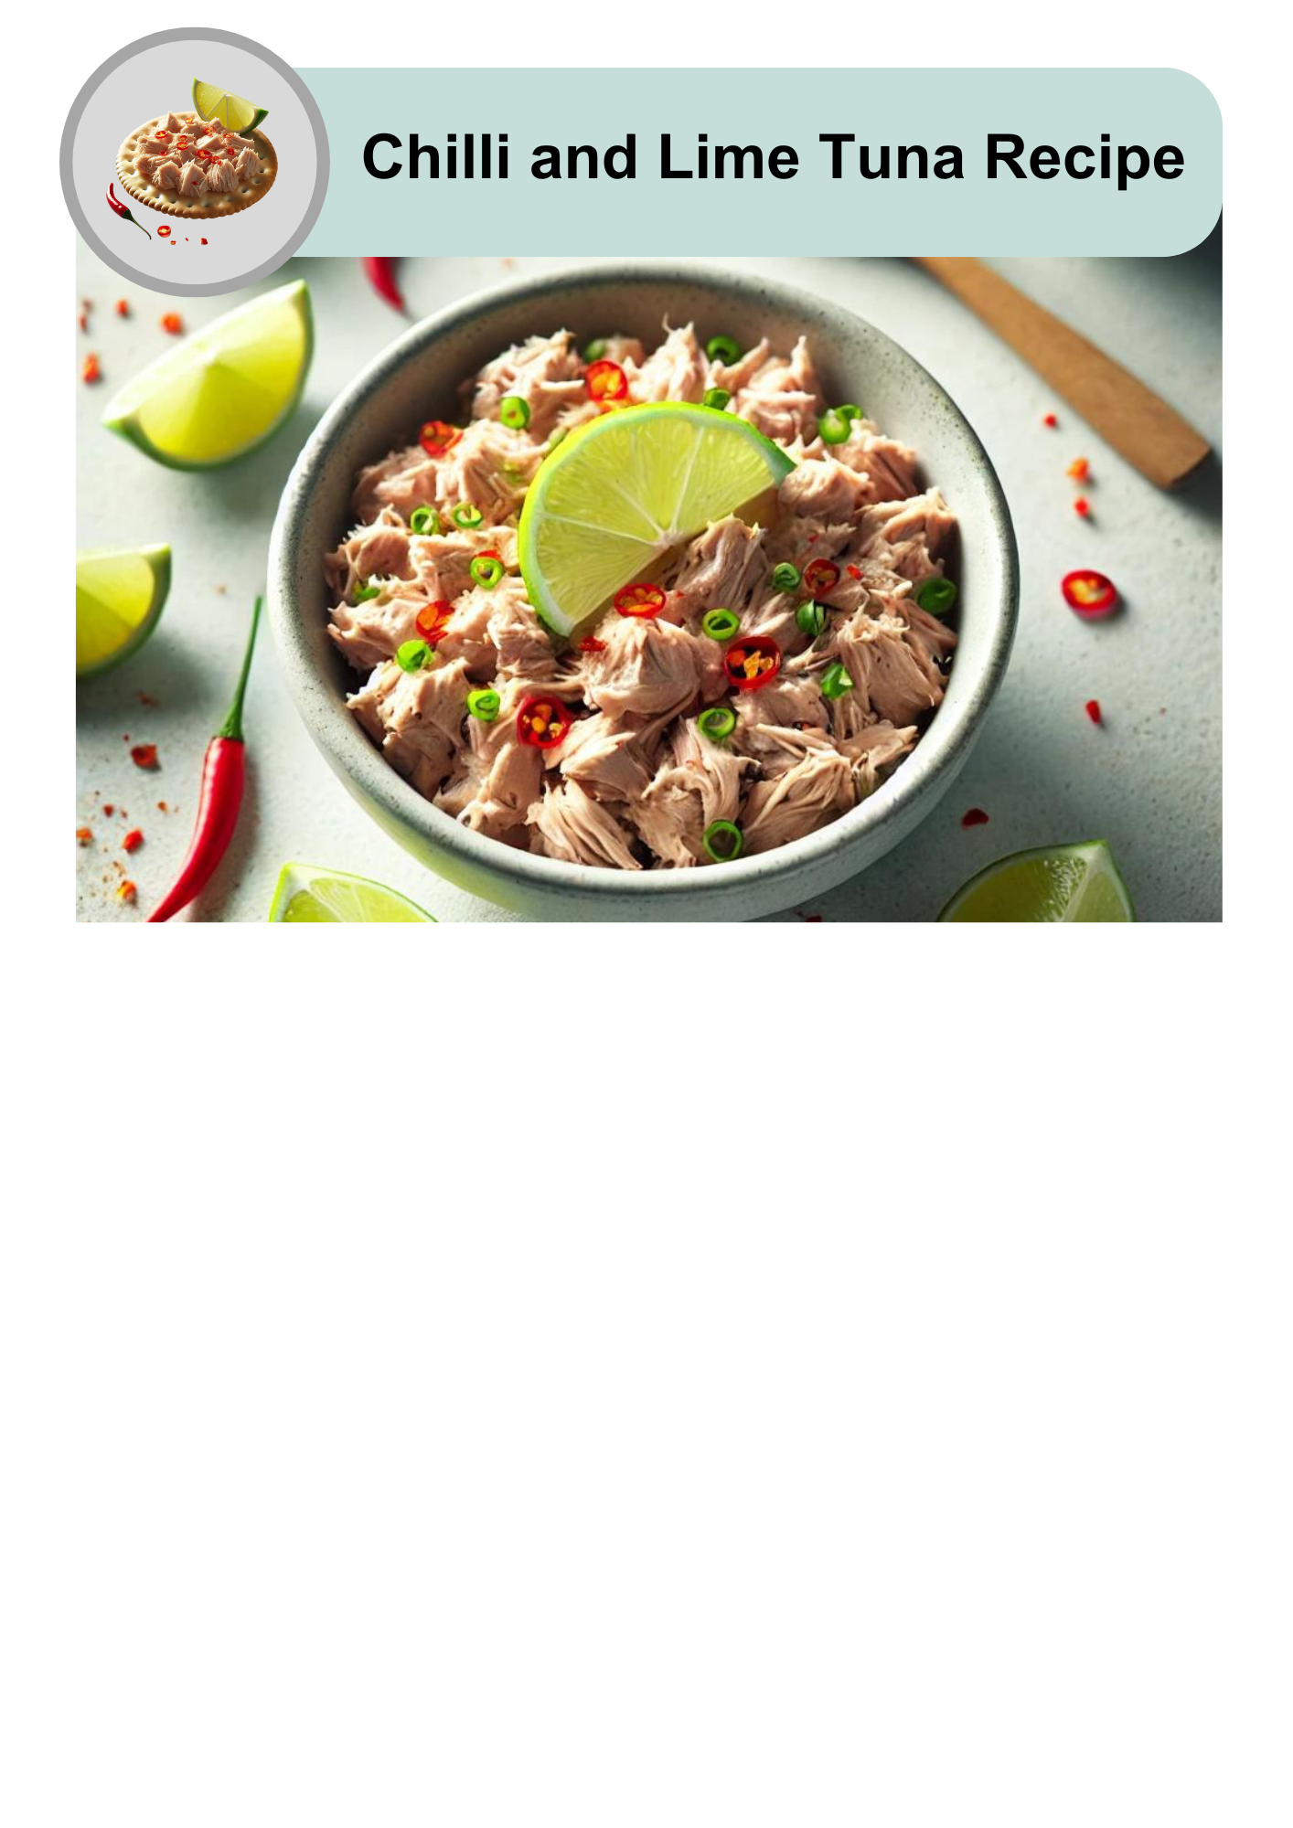

|  |  |
| --- | --- |
| A clock icon with a teal border and white face, showing a highlighted blue segment representing 5 minutes. The number '5' is displayed prominently in black with the word 'min' written below it. | This recipe takes 5 minutes to make. |
| An image of a bowl of chilli and lime tuna garnished with a lime wedge, red chillies, and green onions. Below the bowl are four black stick figure icons representing four servings. | It will serve 4 people. |
| Two shiny metal spoons placed side by side on a plain grey background. | 2 tablespoons is 1 serving. |

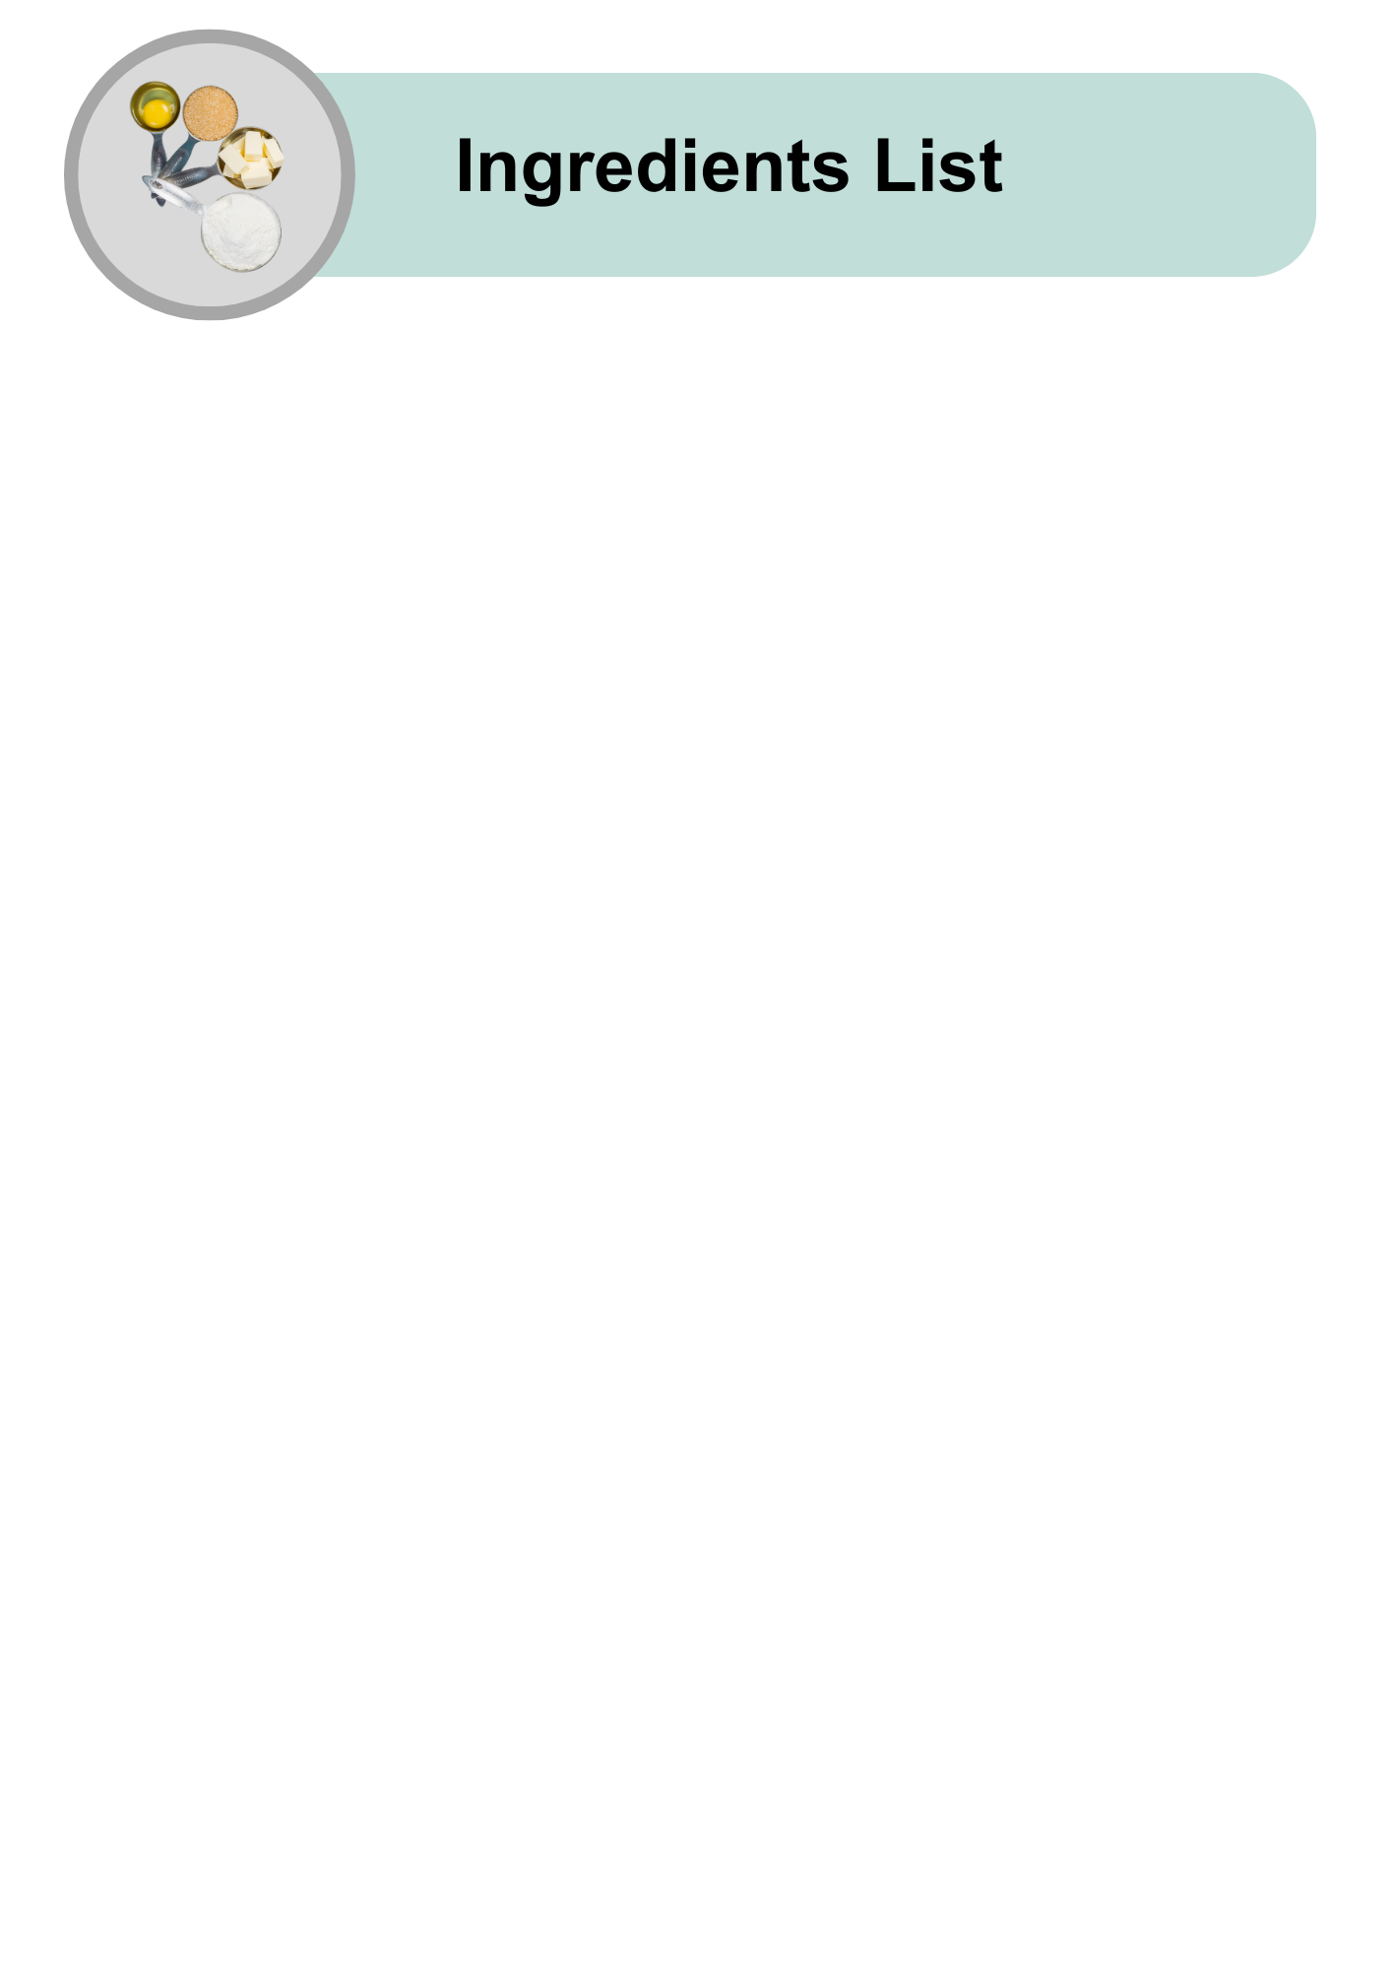

|  |  |
| --- | --- |
| An open gold tin filled with shredded tuna, with water droplets on the outside of the can, placed on a plain grey background. | 400g tin of tuna in Springwater |
| A single bright red chilli pepper with a green stem, placed on a plain grey background. | 1 small fresh red chilli |
| A whole green lime next to a lime half showing its bright green, juicy interior, placed on a plain grey background. | Half a fresh lime |
| A silver measuring spoon filled with golden olive oil, placed on a plain grey background. | 1 tablespoon of Extra Virgin Olive Oil |
| A glass shaker filled with ground black pepper, topped with a shiny silver lid, on a plain grey background. | 1 teaspoon of black pepper |
| A glass shaker filled with white table salt, topped with a shiny silver lid, on a plain grey background. | 1 teaspoon of salt |

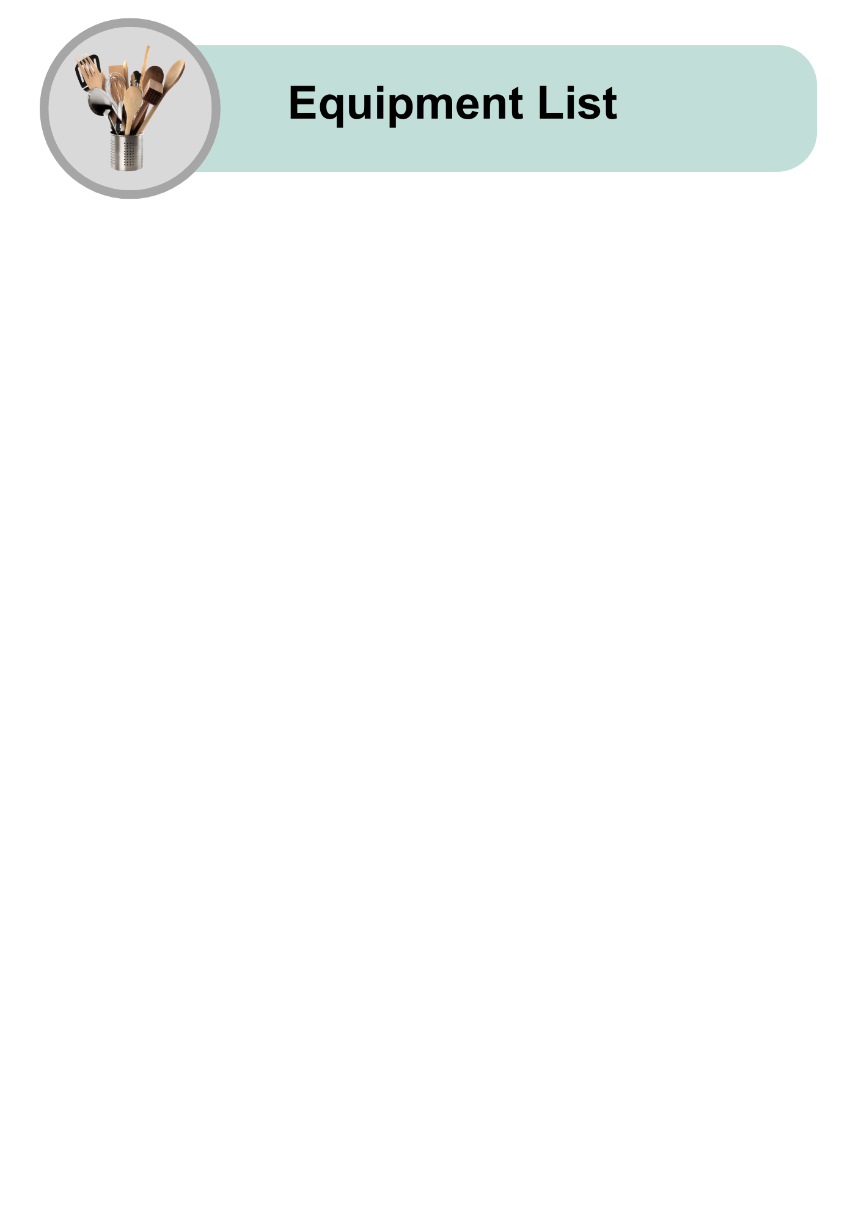

|  |  |
| --- | --- |
| A plain white ceramic bowl with a simple, clean design, placed on a light grey background. | Medium mixing bowl |
| A rectangular wooden cutting board with a handle cutout on one side, placed on a light grey background. | Chopping board |
| A sharp chef’s knife with a wooden handle featuring a polished metal blade, placed on a light grey background. | Large knife |
| A yellow plastic citrus juicer with a ribbed cone and juice strainer, placed on a plain grey background. | Juicer |
| A shiny metal spoon with a simple, reflective design, placed on a light grey background. | Tablespoon |
| A wooden spoon with a smooth finish, placed on a plain grey background. | Large spoon for mixing |
| A smiling woman wearing a red and white striped apron, holding two wooden spoons while stirring a pot. She is surrounded by fresh vegetables, including tomatoes, bell peppers, cucumbers, and a cabbage, on a grey background. | A support person to help open the can safely |

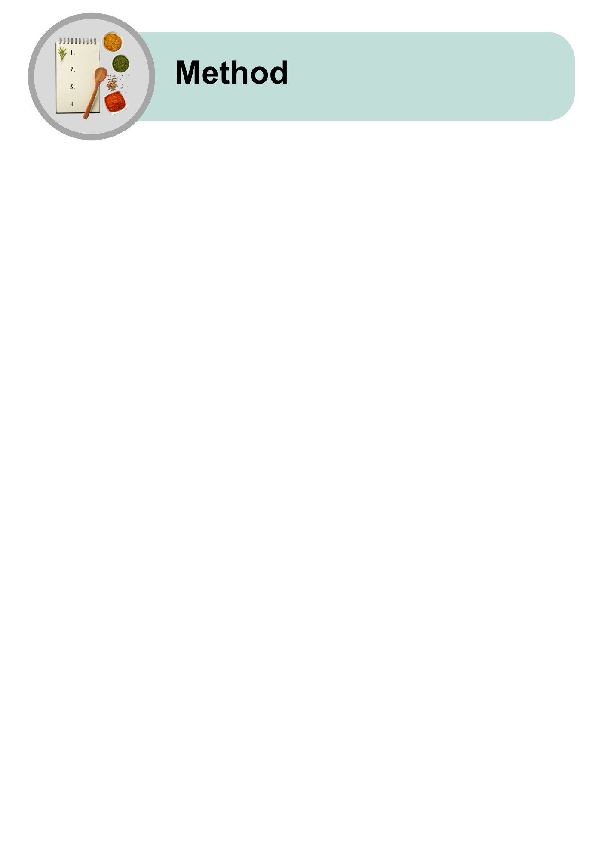

|  |  |
| --- | --- |
| Hands opening a can of tuna with a pull-tab, revealing the contents inside, on a plain grey background. | Ask for help to open the tuna can. |
| A tin can lid with sharp edges, accompanied by a yellow warning sign with an exclamation mark, placed on a plain grey background. | The lid is sharp. |
| A can of tuna being emptied into a plain white bowl, represented by a red arrow pointing from the can to the bowl, on a grey background. | Put the tuna in the bowl. |
| A hand dropping an empty tin can into a white bin with the lid open, symbolising disposal or recycling. | Put the empty can in the bin safely. |
| A whole red chilli and slices of chilli on a grey background. Below them are a knife and a cutting board with a plus sign in between, representing the chopping process. | Cut the chilli into small pieces.  Use the knife on a chopping board. |
| A plain white bowl with sliced chillies falling into it, representing adding chillies to the bowl. | Add the chilli to the bowl. |
| A hand squeezing a lime half over a yellow citrus juicer, with the juicer positioned above a plain white bowl, representing lime juice being added to the bowl. | Squeeze the lime.  Use the juicer.  Add the lime juice to the bowl. |
| A plain white bowl with olive oil, salt, and pepper being added, represented by a spoon of oil and two shakers hovering above the bowl. | Add olive oil, salt, and pepper. |
| A plain white bowl with a spoon inside it and arrows indicating stirring, representing mixing the ingredients. | Mix everything together with a spoon. |
| A vertical arrangement of four food options for serving chilli and lime tuna. From top to bottom: a plate of salad topped with tuna, a black bowl filled with white rice, a sandwich with tuna and lettuce on a white plate, and a colourful nourish bowl with vegetables, corn, beans, and tuna. The accompanying text suggests serving the tuna on a salad, with rice or quinoa, in a sandwich or wrap, or as part of a nourish bowl. | You can eat the chilli and lime tuna:   * On top of a salad * With rice or quinoa * In a sandwich or wrap * As part of a nourish bowl. |

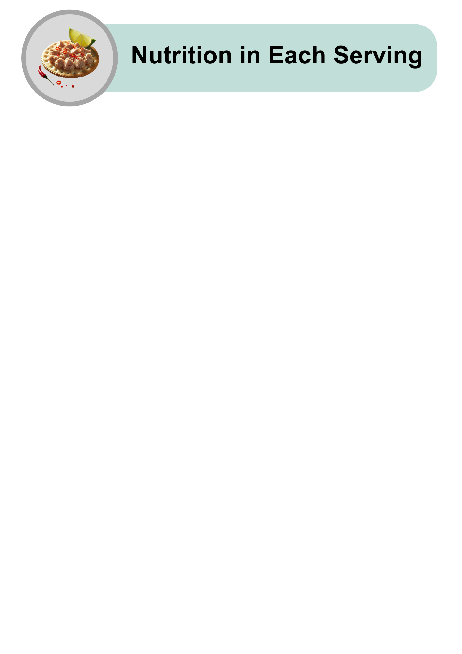

|  |  |  |  |
| --- | --- | --- | --- |
| A cartoon-style illustration of various foods, including chicken, fish, carrots, and an egg, with a lightning bolt icon above, representing energy or nutrients. | | | Quite high in energy |
| An assortment of high-protein foods, including raw salmon, chicken breast, steak, eggs, nuts, grains, and cheese, arranged on a light grey background. | | | High in protein |
| A collection of healthy fat sources, including raw salmon, avocado halves, mixed nuts, and a small bowl of olive oil, placed on a light grey background. | | | High in healthy fat |
| A variety of carbohydrate-rich foods, including pasta, bread, cereal, cookies, juice, and sugar cubes, arranged on a light grey background. | | | Low in carbohydrates |
| An arrangement of sugary treats, including lollipops, chocolate, cookies, candies, and a bowl of sugar with a spoon in the centre, symbolising high-sugar foods. | | | Low in sugars |
| An assortment of whole grains, seeds, nuts, and breads arranged with small bowls of grains, representing healthy fibre-rich foods, on a light grey background. | | | Low in fibre |
| A tilted glass shaker filled with white table salt, with a small pile of salt spilled on the grey surface, representing salt usage or measurement. | | | High in salt |
| A bowl of chilli and lime tuna garnished with a lime wedge, red chillies, and green onions. A hand showing a thumbs-up is placed next to the bowl, symbolising approval. | Chilli and Lime Tuna is easy to make and good for you! | |
| A cracker topped with shredded tuna, sliced chillies, and a lime wedge, placed on a plain grey background, representing a serving suggestion. | Try making this recipe at home.  Enjoy it with your favourite meals. | |
| A hand holding a smartphone displaying the Dietitians Australia website homepage, with the text 'The leading voice in nutrition and dietetics' visible on the screen. | For more recipes and tips, visit the Dietitians Australia website. | |

The Australian Federation of Disability Organisations (AFDO) made this document Easy Read. You need to ask AFDO if you want to use any pictures from this document. You can email AFDO at [office@afdo.org.au](mailto:office@afdo.org.au)