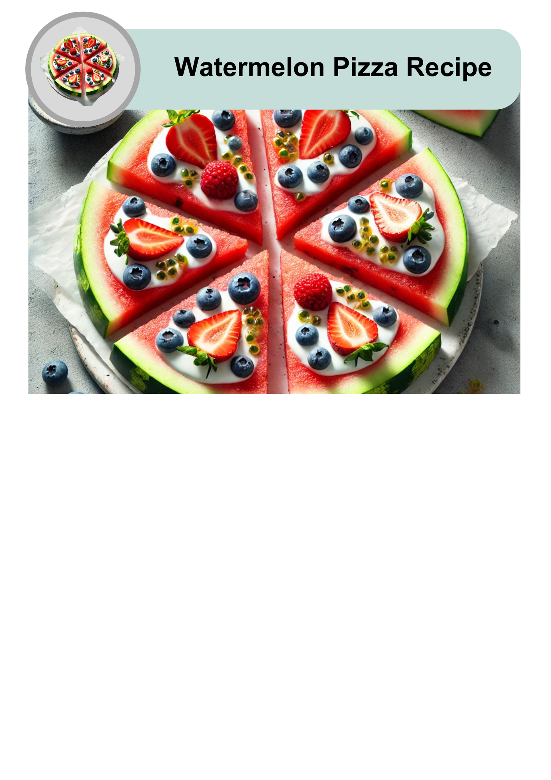

|  |  |
| --- | --- |
| A clock icon showing "15 min" in blue, indicating the time required to prepare the Watermelon Pizza recipe. | This recipe takes 10 to 15 minutes to make. |
| An icon displaying a watermelon pizza with a slice removed above six silhouetted people, indicating the recipe serves six. | It will serve 6 people. |
| Two triangular slices of fresh watermelon with a green rind and red flesh. | 2 slices is 1 serving |



|  |  |
| --- | --- |
| Two circular slices of watermelon showing the red interior and black seeds. | 2 thick slices of watermelon |
| An open yogurt container with a spoon inside, filled with creamy white yogurt. | 6 tablespoons of Greek yoghurt |
| A wooden bowl filled with fresh, ripe blueberries. | 1 cup of blueberries |
| A bowl filled with red strawberries, some with green leaves still attached. | 1 cup of strawberries |
| A small glass bowl filled with passionfruit pulp, next to a halved passionfruit. | 2 tablespoons of passionfruit pulp |



|  |  |
| --- | --- |
| A wooden chopping board with a handle. | Chopping board |
| A sharp chef’s knife with a wooden handle. | Sharp knife |
| A silver tablespoon with a reflective surface. | Tablespoon |
| Six white plates arranged in two rows. | 6 plates |
| A smiling woman in a red striped apron, cooking in a pot surrounded by fresh vegetables. | A support person to help with the knife |

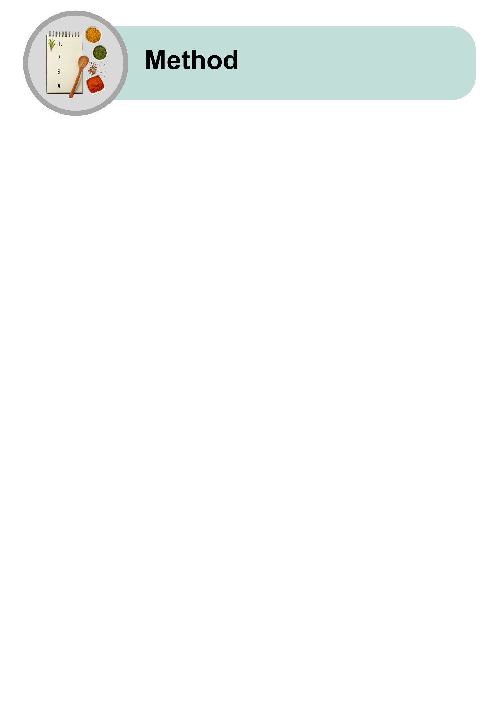

|  |  |
| --- | --- |
| A whole round watermelon placed above a knife and a cutting board, indicating that the watermelon will be cut. | Cut 2 thick slices from the middle of the watermelon. |
| A person standing below a ruler showing 0 to 2 cm, indicating they will cut the watermelon into slices of about 2 cm thickness. | Ask a support person for help if you need it.  Make each slice 2-3 cm thick. |
| A container of yogurt with a spoon above a round watermelon, with an arrow pointing downward, showing that the yogurt will be spread on top of the watermelon. | Spread 3 tablespoons of yoghurt on each watermelon slice. |
| A bowl of fresh strawberries placed above a knife and a cutting board, indicating that the strawberries will be sliced. | Chop the strawberries into slices. |
| A bowl of strawberries placed above a watermelon, with an arrow pointing downward, indicating that the strawberries will be added to the watermelon. | Put the strawberries on top of the yoghurt. Spread them out evenly. |
| A bowl of fresh blueberries placed above a watermelon, with an arrow pointing downward, indicating that blueberries will be added to the watermelon. | Put the blueberries on top with the strawberries. |
| A small glass bowl containing passionfruit pulp placed above a watermelon, with an arrow pointing downward, indicating that passionfruit pulp will be added on top of the watermelon. | Spoon the passionfruit over the berries and yoghurt. |
| A completed watermelon pizza with fruit toppings being cut into slices on a cutting board. | Cut each watermelon slice into 6 triangle pieces. |
| Watermelon pizza slices being transferred to six plates for serving. | Put the watermelon pizza slices on the plates and eat straight away. |
| Icons representing different serving ideas: as part of a fruit platter, with ice cream, or as a party dish. | Eat watermelon pizza:   * As a snack * For dessert * At a party. |

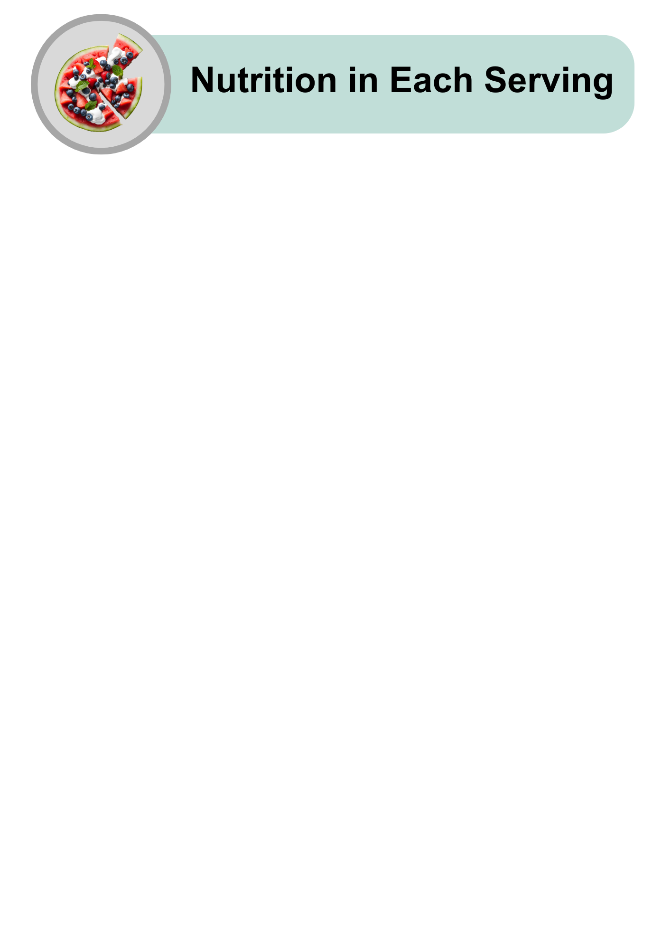

|  |  |
| --- | --- |
| A cartoon-style illustration of various foods, including chicken, fish, carrots, and an egg, with a lightning bolt icon above, representing energy or nutrients. | Low in energy |
| An assortment of high-protein foods, including raw salmon, chicken breast, steak, eggs, nuts, grains, and cheese, arranged on a light grey background. | Low in protein |
| A collection of healthy fat sources, including raw salmon, avocado halves, mixed nuts, and a small bowl of olive oil, placed on a light grey background. | Low in fat |
| A variety of carbohydrate-rich foods, including pasta, bread, cereal, cookies, juice, and sugar cubes, arranged on a light grey background. | High in carbohydrates |
| An arrangement of sugary treats, including lollipops, chocolate, cookies, candies, and a bowl of sugar with a spoon in the centre, symbolising high-sugar foods. | Quite high in natural sugars |
| An assortment of whole grains, seeds, nuts, and breads arranged with small bowls of grains, representing healthy fibre-rich foods, on a light grey background. | High in fibre |
| A tilted glass shaker filled with white table salt, with a small pile of salt spilled on the grey surface, representing salt usage or measurement. | Low in salt |
| A hand giving a thumbs-up next to a watermelon pizza slice, indicating the dish is delicious and approved. | Watermelon Pizza easy to make and good for you! |
| A hand holding a smartphone displaying the Dietitians Australia website homepage, with the text 'The leading voice in nutrition and dietetics' visible on the screen. | For more recipes and tips, visit the Dietitians Australia website. |

The Australian Federation of Disability Organisations (AFDO) made this document Easy Read. You need to ask AFDO if you want to use any pictures from this document. You can email AFDO at [office@afdo.org.au](mailto:office@afdo.org.au)