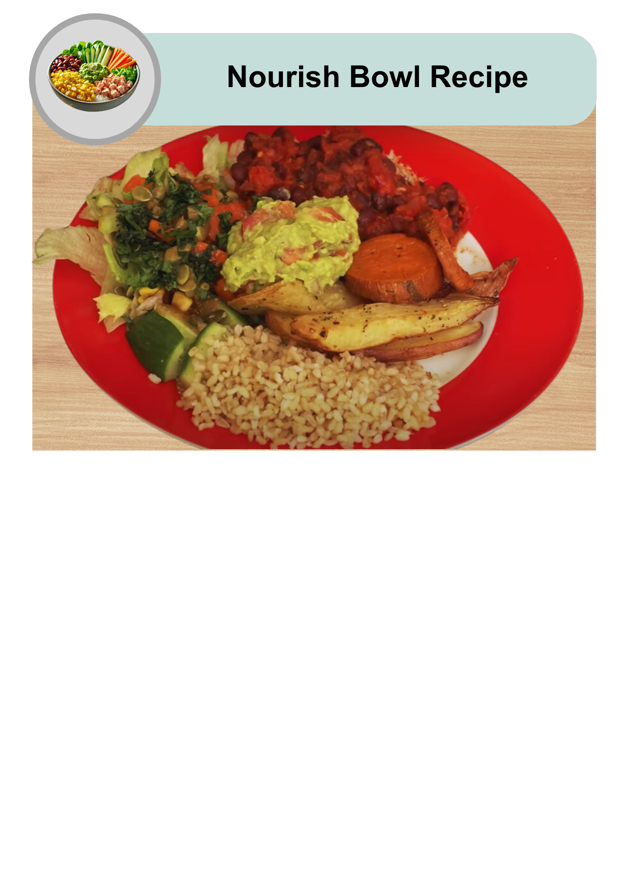

|  |  |
| --- | --- |
| A hand giving a thumbs up next to a nourish bowl filled with colourful vegetables, corn, guacamole, and diced protein on rice. | A nourish bowl is a healthy meal. |
| A four-part circle showing cartoon-style food icons: bread, meat, fruit/vegetables, and dairy/oil, each in a different colour quadrant. | It has different foods on one plate. |
| A nourish bowl with a hand giving a thumbs up and a red heart with a white checkmark, symbolising a healthy, approved meal. | You can choose foods that are good for you and that you like to eat. |
| A black and white image of a traditional alarm clock showing the time as 10:10. | This recipe takes some time to make. |
| A nourish bowl above six black human stick figure icons, representing that the recipe serves six people. | It will serve 4 to 6 people. |
| A red plastic measuring cup shown from the top, used for measuring ingredients. | 1 cup is 1 serving. |

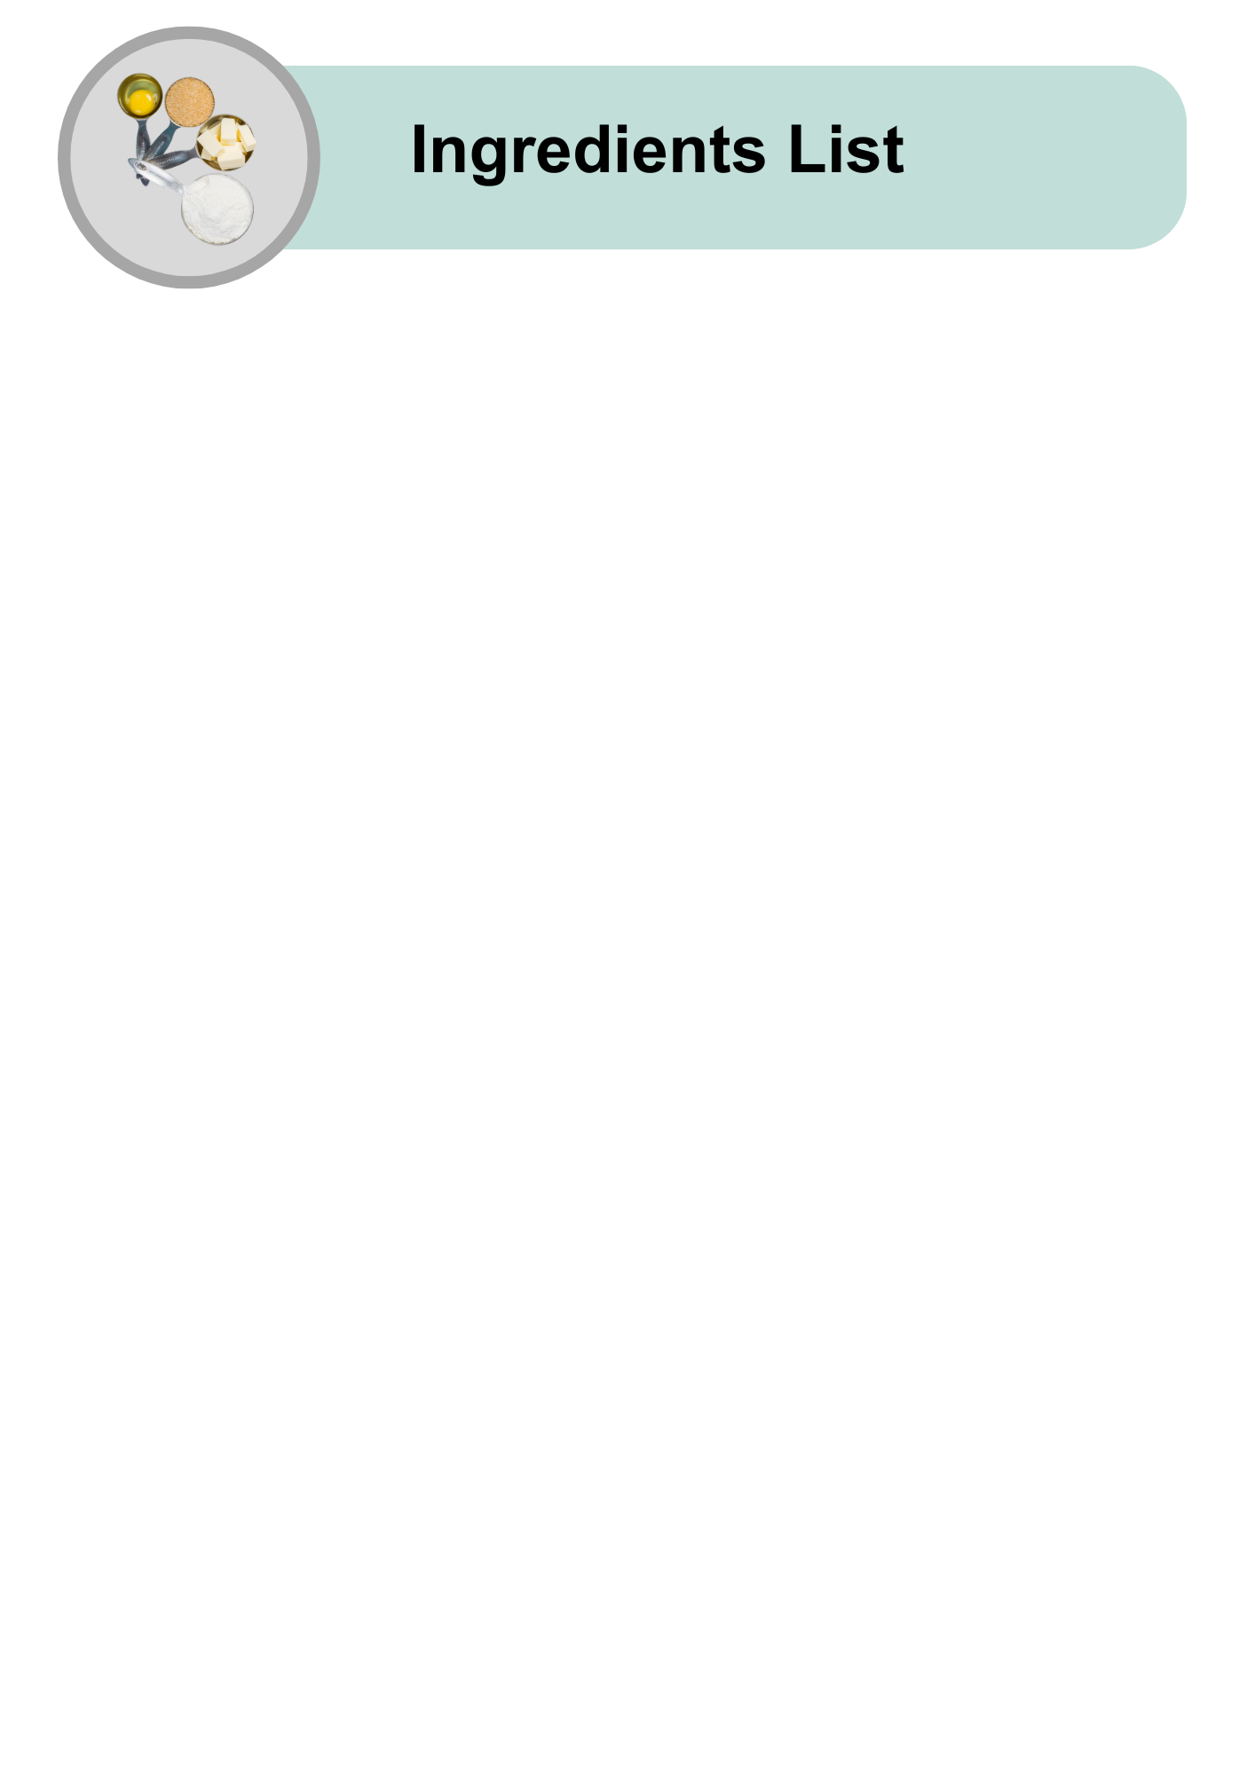

|  |  |
| --- | --- |
| Two fresh, whole carrots with green tops on a light grey background. | 2 carrots |
| A silver tin can with the lid removed, filled with bright yellow corn kernels on a light grey background. | 1 tin of corn (400g) |
| A white bowl filled with crisp green lettuce leaves on a light grey background. | 3 cups of lettuce |
| A cucumber with part of it sliced into round pieces, showing the fresh, pale green interior. | 1 cucumber |
| A bunch of fresh coriander leaves with jagged edges and bright green colour, viewed from above. | A handful of coriander leaves |
| A small brown bowl filled with green pumpkin seeds (pepitas) on a light grey background. | 3 tablespoons of pepitas |
| A brown resealable packet labelled "Brown Rice" with an image of a bowl of cooked brown rice on the front. | 1 packet of cooked brown rice |
| A plate with roasted sweet potato wedges, lightly seasoned and arranged neatly on a wooden surface. | Herby Potatoes |
| A bowl of spicy beans with visible whole beans, diced vegetables, and garnished with parsley. | Spicy Beans |
| A terracotta bowl filled with chunky guacamole made from mashed avocado and finely chopped vegetables. | Guacamole |
| A round cracker topped with chunks of tuna, red chilli slices, and a lime wedge, with a red chilli pepper placed beside it. | Chilli and Lime Tuna |

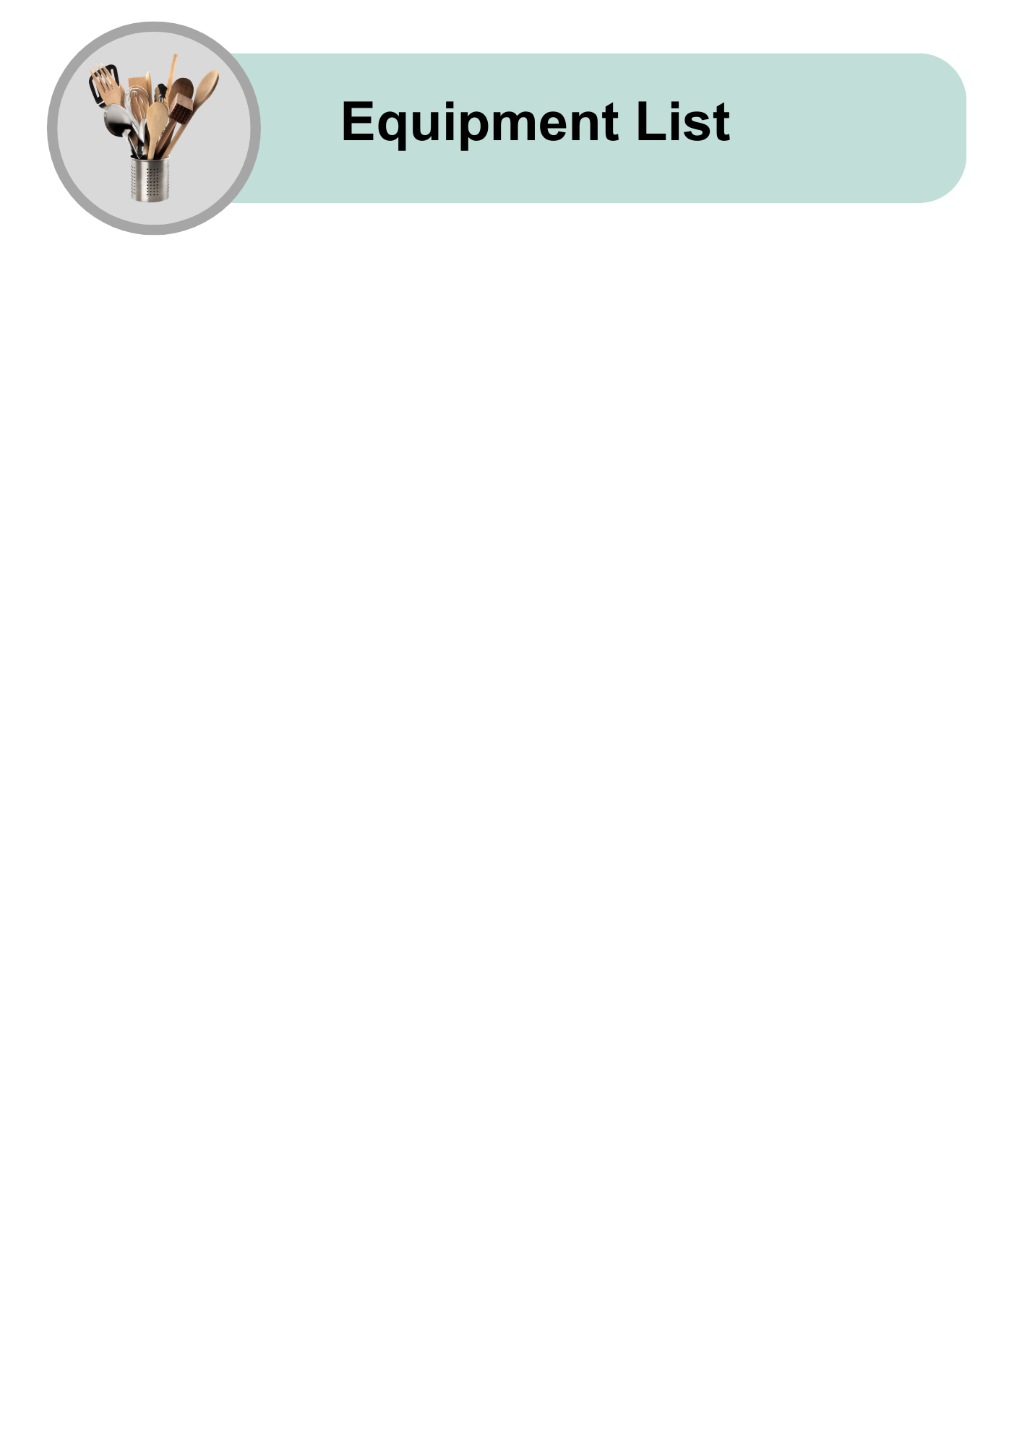

|  |  |
| --- | --- |
| A small rectangular wooden cutting board with a hand grip slot on the left side. | Chopping board |
| A kitchen knife with a silver blade and a brown wooden handle. | Large knife |
| A standard metal spoon with a reflective surface. | Tablespoon |
| A white ceramic mixing bowl placed on a light background. | Large bowl |
| A manual can opener with white and grey handles and metal cutting components. | Can opener |
| A woman wearing a red striped apron stirring food in a pot, surrounded by fresh vegetables including capsicum, cabbage, and tomatoes. | A support person to help |

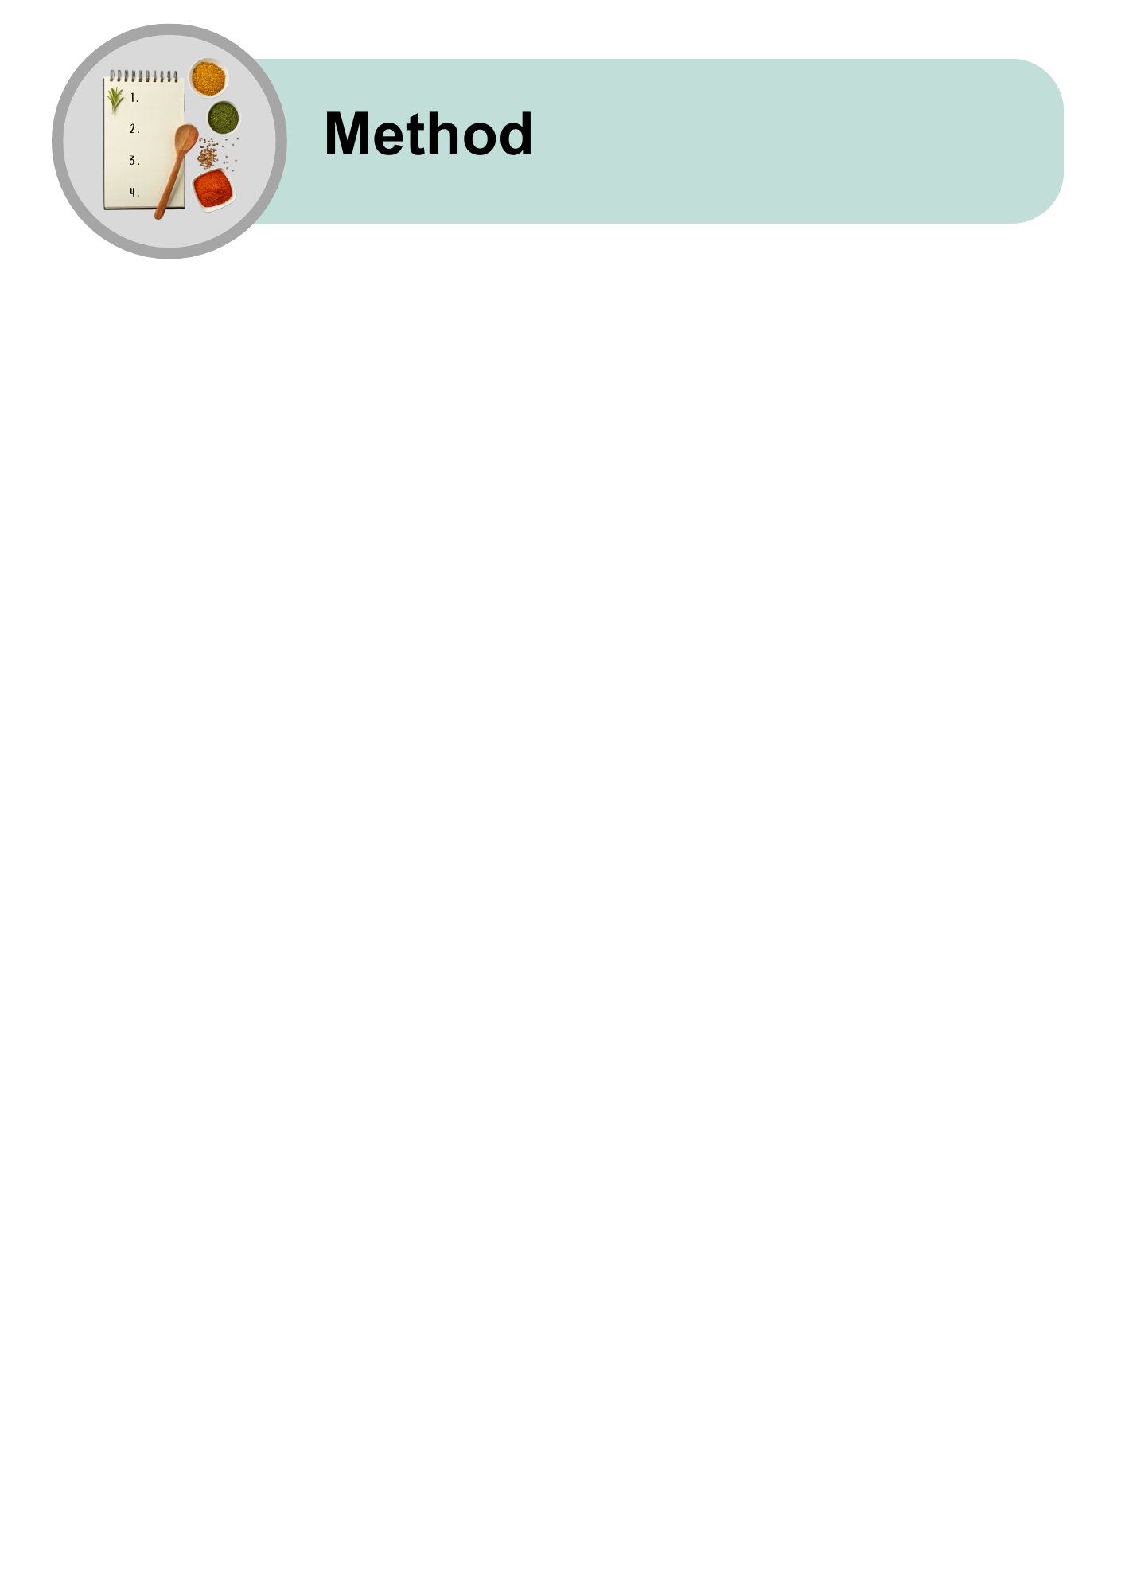

|  |  |
| --- | --- |
| A plate with roasted sweet potato wedges, lightly seasoned and arranged neatly on a wooden surface. | **Make the Herby Potatoes.**  Follow the [Herby Potatoes Recipe here.](https://dietitiansaustralia.org.au/sites/default/files/2025-02/Herby%20Potato%20Recipe%20-%20Easy%20Read.pdf) |
| A bowl of spicy beans with visible beans, diced vegetables, and garnished with parsley. | **Make the Spicy Beans.**  Follow the [Spice Beans Recipe here.](https://dietitiansaustralia.org.au/sites/default/files/2025-02/Spicy%20Beans%20Recipe%20-%20Easy%20Read.pdf) |
| A terracotta bowl filled with chunky guacamole made from mashed avocado and finely chopped vegetables. | **Make the Guacamole.**  Follow the [Guacamole Recipe here.](https://dietitiansaustralia.org.au/sites/default/files/2025-02/Guacamole%20Recipe%20-%20Easy%20Read.pdf) |
| A round cracker topped with chunks of tuna, red chilli slices, and a lime wedge, with a red chilli pepper placed beside it. | **Make the Chilli and Lime Tuna.**  Follow the [Chilli and Lime Tuna Recipe here.](https://dietitiansaustralia.org.au/sites/default/files/2025-03/Chilli%20and%20Lime%20Tuna%20Recipe%20-%20Easy%20Read.pdf) |
| Chopped carrot sticks above a knife and cutting board, showing the tools used to cut the carrots. | Cut the carrots into small sticks. |
| A silver tin can tipped over, spilling bright yellow corn kernels onto the surface. | Drain the corn. |
| A pair of hands rinsing fresh green lettuce under running water from a kitchen tap. | Wash and dry the lettuce leaves. |
| A cucumber partly sliced into round pieces, with a knife and wooden chopping board below, showing the tools used. | Slice the cucumber. |
| Fresh coriander above a knife and wooden chopping board, showing ingredients and tools needed for chopping. | Chop the coriander. |
| Hands holding a clear rice packet with an overlay of a checklist icon, symbolising checking cooking instructions. Below is a woman in a red striped apron preparing food. | Follow the instructions on the packet to cook the brown rice.  Ask your support person for help if you need it. |
| A filled nourish bowl arranged with colourful ingredients including kidney beans, corn, tuna, carrot sticks, cucumber, lettuce, wild rice, cherry tomatoes, and guacamole. | **Put the Nourish Bowl together.** |
| **Two circular images - one of shredded tuna and one of bean stew - above an empty white bowl with an arrow pointing down, suggesting adding one protein choice.** | * **Add some protein:** Spicy Beans or Chilli and Lime Tuna. |
| Two images - one bowl of cooked brown rice and one plate of roasted sweet potato - above an empty white bowl with an arrow pointing down, indicating adding one carb option. | * **Add some carbohydrates:** Herby Potatoes or rice. |
| Chopped lettuce, carrot sticks, corn, and cucumber slices arranged above an empty white bowl with a down arrow, indicating they are to be added. | * **Add lots of salad:** Lettuce, carrots, corn, and cucumber. |
| Guacamole, coriander, pumpkin seeds, and olive oil above a white bowl with an arrow pointing down, showing they are final toppings to add. | **On top:** Add guacamole, coriander, seeds, or a little olive oil. |

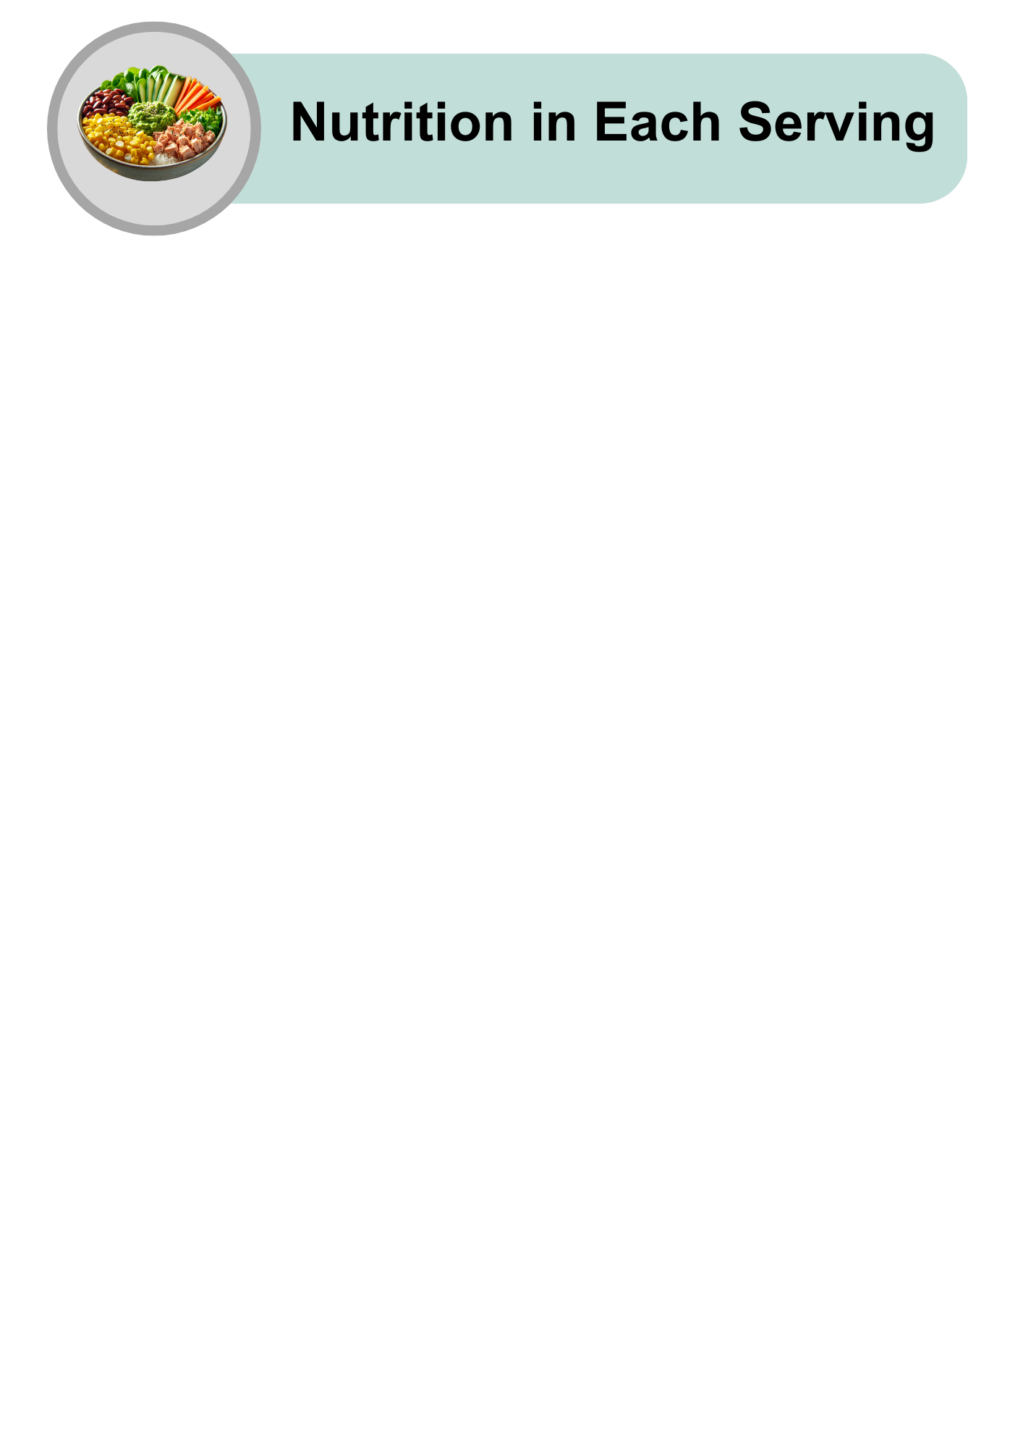

|  |  |
| --- | --- |
| Illustrated icons of a chicken drumstick, fish fillet, carrot, and egg under a lightning bolt symbol, representing energy-giving foods. | Quite high in energy |
| A wide variety of high-protein foods including salmon, chicken, beef, cheese, eggs, tofu, legumes, broccoli, and whole grains arranged together. | Quite high in protein |
| A selection of healthy fats including salmon, avocado, nuts, and a small bowl of oil. | Low in fat |
| A group of refined carbohydrate foods such as pasta, white bread, cookies, cereal, marshmallows, orange juice, and soft drink. | High in carbohydrates |
| A central bowl of white sugar surrounded by lollies, chocolates, cookies, and sweets. | Quite high in sugars |
| A variety of whole grain breads, seeds, nuts, and cereals arranged with small bowls of grains and crackers. | High in fibre |
| A tipped-over glass salt shaker with a small pile of white salt next to it. | Low in salt |
| A nourish bowl with vegetables, beans, corn, and protein above a hand giving a thumbs-up sign, indicating a healthy meal choice. | A nourish bowl easy to make and good for you! |
| A colourful nourish bowl featuring kidney beans, corn, rice, tuna, guacamole, cucumber, carrot sticks, lettuce, and cherry tomatoes, arranged neatly in sections. | Try making this recipe at home.  Enjoy it with your favourite meals. |
| A hand holding a smartphone displaying the Dietitians Australia website with the text: “The leading voice in nutrition and dietetics.” | For more recipes and tips, visit the Dietitians Australia website. |

The Australian Federation of Disability Organisations (AFDO) made this document Easy Read. You need to ask AFDO if you want to use any pictures from this document. You can email AFDO at [office@afdo.org.au](mailto:office@afdo.org.au)