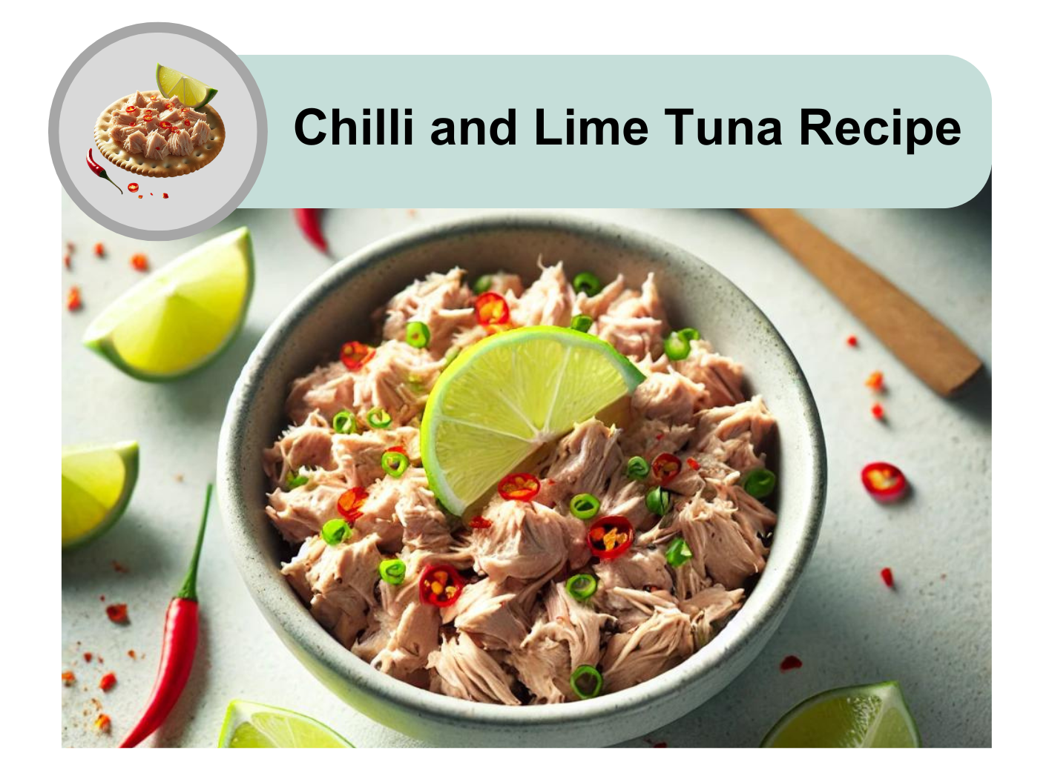

 | This recipe takes 5 minutes to make.
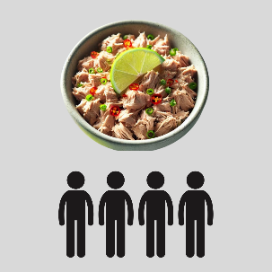 | It will serve 4 people.
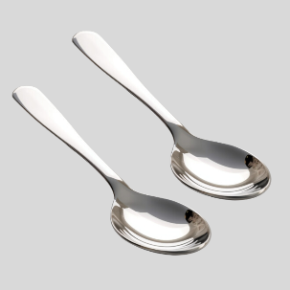 | 2 tablespoons is 1 serving.


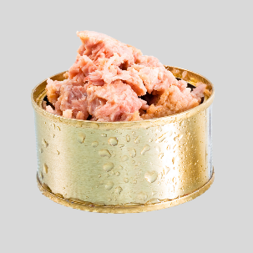 | 400g tin of tuna in Springwater
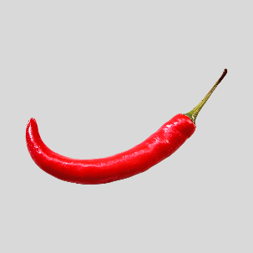 | 1 small fresh red chilli
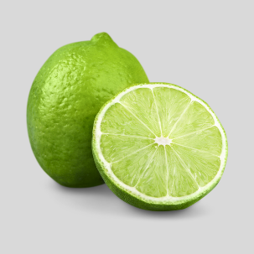 | Half a fresh lime
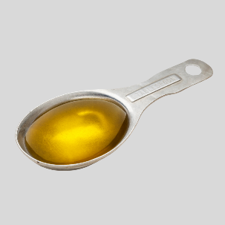 | 1 tablespoon of Extra Virgin Olive Oil
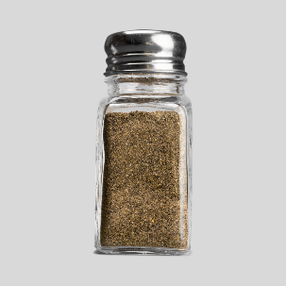 | 1 teaspoon of black pepper
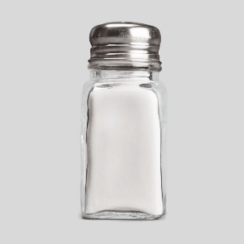 | 1 teaspoon of salt

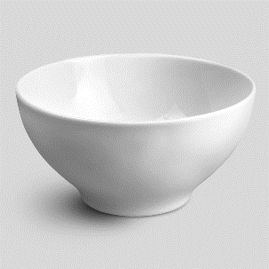 | Medium mixing bowl
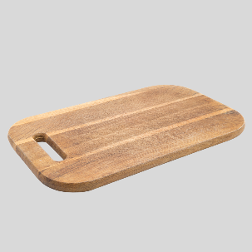 | Chopping board
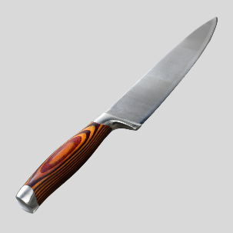 | Large knife
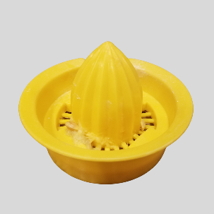 | Juicer
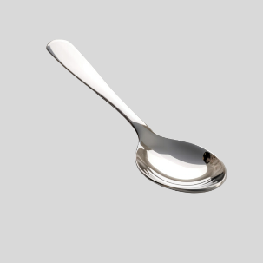 | Tablespoon
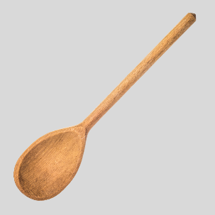 | Large spoon for mixing
 | A support person to help open the can safely


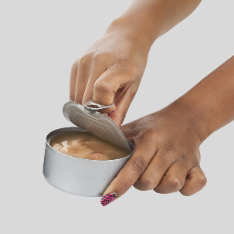 | Ask for help to open the tuna can.
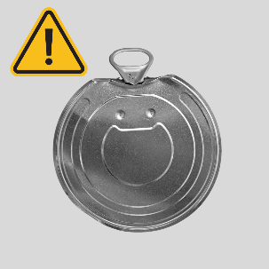 | The lid is sharp.
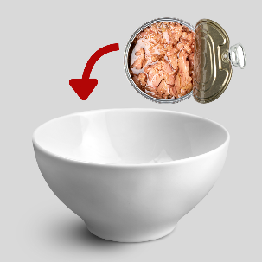 | Put the tuna in the bowl.
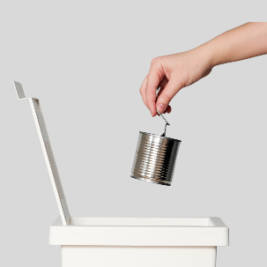 | Put the empty can in the bin safely.
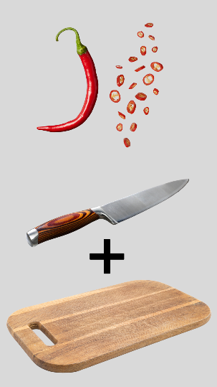 | Cut the chilli into small pieces.  Use the knife on a chopping board.
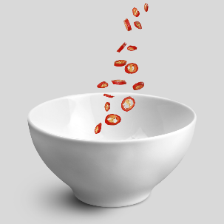 | Add the chilli to the bowl.
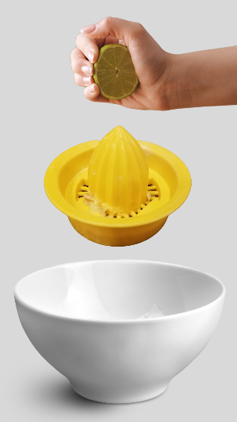 | Squeeze the lime.  Use the juicer.  Add the lime juice to the bowl.
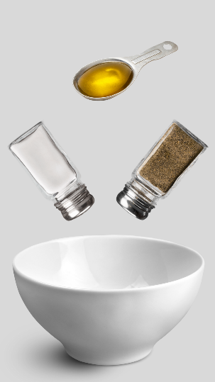 | Add olive oil, salt, and pepper.
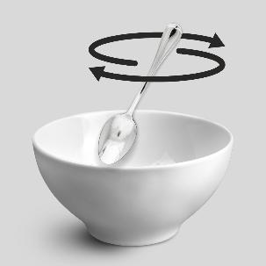 | Mix everything together with a spoon.
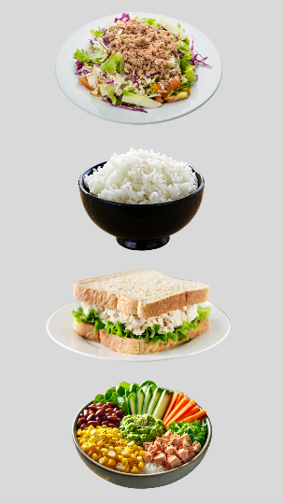 | You can eat the chilli and lime tuna:  - On top of a salad  - With rice or quinoa  - In a sandwich or wrap  - As part of a nourish bowl.


 |  |  | Quite high in energy
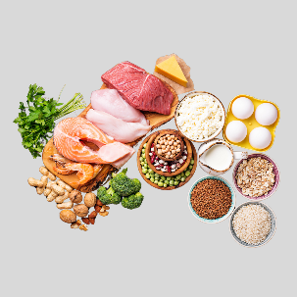 |  |  | High in protein
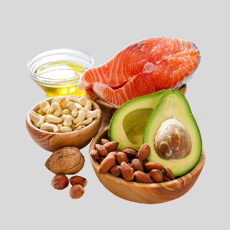 |  |  | High in healthy fat
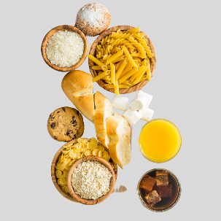 |  |  | Low in carbohydrates
 |  |  | Low in sugars
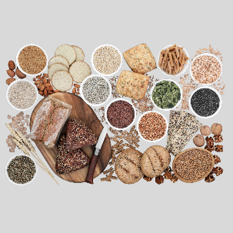 |  |  | Low in fibre
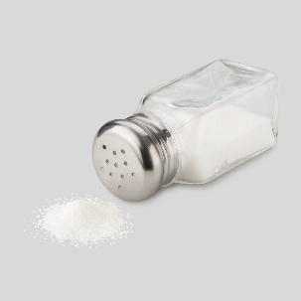 |  |  | High in salt
 | 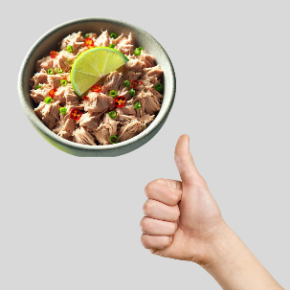 | Chilli and Lime Tuna is easy to make and good for you!
 | 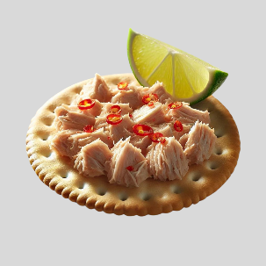 | Try making this recipe at home.  Enjoy it with your favourite meals.
 |  | For more recipes and tips, visit the Dietitians Australia website.

The Australian Federation of Disability Organisations (AFDO) made this document Easy Read. You need to ask AFDO if you want to use any pictures from this document. You can email AFDO at office@afdo.org.au

